NEWSWATCH



**Vol. 2017-2018 No. 3 October 2017**

**_________________________________________________________________________________­­­­­­**

**Next meeting: 2 p.m., Wednesday, November 8**

**Peterson Room, Showalter House, IU Foundation, SR46 Bypass**

**Coming in November: Everything you**

**want to know about retiree benefits**



At this time of year mailboxes overflow with the first holiday catalogs and various health insurance offers. At the Nov. 8 IURA meeting, representatives from IU Human Resources will offer information about insurance plans available through IU. IURA Benefits Chair **Bruce Jaffee** will answer questions about benefits that are not administered by HR, and a sheet describing retiree benefits will be available. Retirees will gather at 2 p.m. at the IU Foundation’s Showalter House.

“At the October meeting IURA members heard about challenges and opportunities facing the U.S. health care system,” Bruce said. *(See following article.)* “Along with President Trump’s executive orders, failure to repeal, replace, or improve the Affordable Care Act has created much uncertainty about the future.” At least in the short run, however, it appears that Medicare and Medicare supplement plans are not undergoing significant change.

“In November, HR’s **Robin Reynolds** will discuss IU’s Anthem Blue supplement plan in this environment. The supplement plan is not a standard Medigap policy, although it has similar – and in some dimensions better – coverage. It is available to IU retirees and their spouses who have had continuous medical coverage through IU,” Bruce explained.

In an Oct. 17 email, **Susan Brewer**, director of HR Benefits wrote, “By the time of the meeting, retirees already should have their annual information packets for the Blue Retiree plan. There is no premium increase and no change in benefits. There will be a change to the plan for retirees under 65. A mailing to retirees in the next few weeks will be specific to each retiree’s own enrollment.”

“Come with your questions,” says IURA President **Joanie Curts**.

**Fix broken health care system with single-payer system, Stone tells retirees**

“Every system is perfectly designed to get the results it gets.”

*Paul Batalden, Dartmouth School of Medicine*

At the IURA’s Oct. 11 meeting at the Alumni Center, **Rob Stone**, M.D., cited this quotation as he described the problems with American health care. Our system is designed to provide maximum profit, not maximum care, he said. The U.S. is the only developed country that doesn’t provide health care to all its citizens, and “no peer-reviewed data suggests that we have the best health care in the world – although we certainly have the most expensive.”

In fact, although the U.S. spends 18 percent of GDP on health care, it has one of the lowest life expectancies of any developed country. U.S. health care is terrifically inefficient, Rob said, with a patchwork quilt of coverage.

“The private insurance industry is the least efficient of all,” he said, “spending lots of money figuring out how to avoid paying for sick care.” Nearly a third of health care expenditures – 31 percent – go to overhead administrative costs, compared to 4 to 6 percent in peer nations.

Health care has long been a political football, Rob said. President Truman repeatedly fought for a national health insurance program, but the American Medical Association called it socialized medicine and Democrats opposed it because their Southern base did not want to see hospitals integrated.

Before the Affordable Care Act of 2010, nearly 50 million Americans were uninsured. After the ACA that number was practically halved, to 28 million. If the ACA had been fully implemented, with all states expanding Medicaid as did Indiana and 30 other states, 22 million Americans would be uninsured.

The 2017 American Health Care Act, passed by the U.S. House but not by the Senate, is, according to Rob, “a political gesture and a huge tax cut for the wealthy, not serious health care legislation.”

Rob believes a shift has taken place. As a candidate, President Trump consistently and repeatedly favored universal health care, saying “I’m going to take care of everybody.” In two polls in August, a majority of physicians said they favor health care for all. Princeton’s Angus Deaton, who won the Nobel Prize for economics in 2015, wrote this summer, “I, who do not believe in socialized health care, would advocate a single-payer system because it will … allow capitalism to flourish without the awful things that health care is doing to us.”



One solution, Rob said, is to expand the Medicare program to everyone, incrementally adding age ranges. At the same time, Rob advocates improving the system by removing co-pays and deductibles. “A lot of people can’t afford supplemental insurance,” he pointed out.

He recalled the words of “All My Trials”: “If religion were a thing that money could buy, the rich would live and the poor would die.” Those words are true of our health care system, he said, and letting the poor die is un-American. Growing up in a staunchly Republican household in Evansville, Rob said he learned from his father that fairness is an American value. From his mother he learned that we must take care of each other. He believes the time has come to do so.

The more than 50 retirees who attended found the presentation thought-provoking. As they munched on cookies provided by **Mary Ellen Anderson**, **Jo Anne Bowen**, and **Doris Fox**, retirees exchanged ideas and reactions. **Don Granbois** found cause for optimism in the shift in public opinion about universal coverage, and he thought incrementally adding people to Medicare rolls might be a workable solution. **Bob Port** called Rob “a clear explainer” who surmounted the difficulties that made it impossible to show his carefully prepared slides. Despite the challenges of downsizing the lucrative insurance business, Bob felt the presentation offered a path to health care for all.

In introducing the speaker, IURA Vice President **Doug Porter** pointed out that Rob was an emergency room physician for 28 years. Since 2011 he has directed his energies to hospice and palliative care. **Phil Henson** and **Sandy Churchill** paid tribute to the speaker’s compassion, which they experienced first hand when their spouses died.

**Library offers help for non-techies**

The Monroe County Public Library offers Tech Days, when you can bring in your digital device and get one-on-one help. You can learn how to access the library’s free eBooks, movies, and music, and you can also receive help with email, Facebook, and other digital resources. Four sessions are scheduled in November. At the main library, Program Room 2C, second floor:

Nov. 7 and 28, from 2 to 4 p.m.

Nov. 16, from 4 to 6 p.m.

At the Ellettsville branch, Nov. 13, from 3 to 5 p.m.

**University Club to feature NASA, 1960s**

The University Club, one of the IURA’s partner organizations, has its eyes on the skies. On Nov. 9, Ken Crawford will speak at the University Women’s Club luncheon at 11:45 a.m. about NASA’s development of the manned space program from Mercury through Gemini and Apollo, the development of the space shuttle, NASA missions from 1981 to 2011 and the astronauts who flew them. Men are welcome to attend. The UClub will relive the 1960s with a party Nov. 17 at 5:30 p.m. Both events are in the University Club Presidents’ Room.

For reservations and menu choices, call the UClub office at 812-855-1325 or email [uclub@indiana.edu](mailto:uclub@indiana.edu).

**Emeriti House welcomes retirees**

The Emeriti House offers weekly programs of interest to IURA members. **Bill McGregor**, director of the Emeriti House, is also an IURA board member. He points out that programs are advertised on the website: <http://www.indiana.edu/~emeriti>.

“Any IURA member who wishes to receive listserv mailings that continually update the master schedule can make that request by emailing [emeriti@indiana.edu](mailto:emeriti@indiana.edu),” Bill says.

**Martin, Burton, Pfister: What a great team**

Before health reasons made it necessary for him to resign from his decades-long service on the IURA’s United Way campaign team, **Wain Martin** drafted a letter to retirees. In his description of retirees, he inadvertently described himself: “IU retirees are an incredibly generous, community-minded people who believe in assisting those among us who are less fortunate than ourselves.”

For longer than they can remember, Wain, **Doris Burton,** and **Harriet Pfister** led the IURA’s United Way efforts, inspiring retirees by their sterling example. Although Wain and Doris have stepped down this year, the indefatigable Harriet continues to contribute her leadership. As we make our United Way pledges this year, let us do so with gratitude for this inspiring threesome – and for **Eileen Schellhammer**, who has volunteered to assist Harriet.

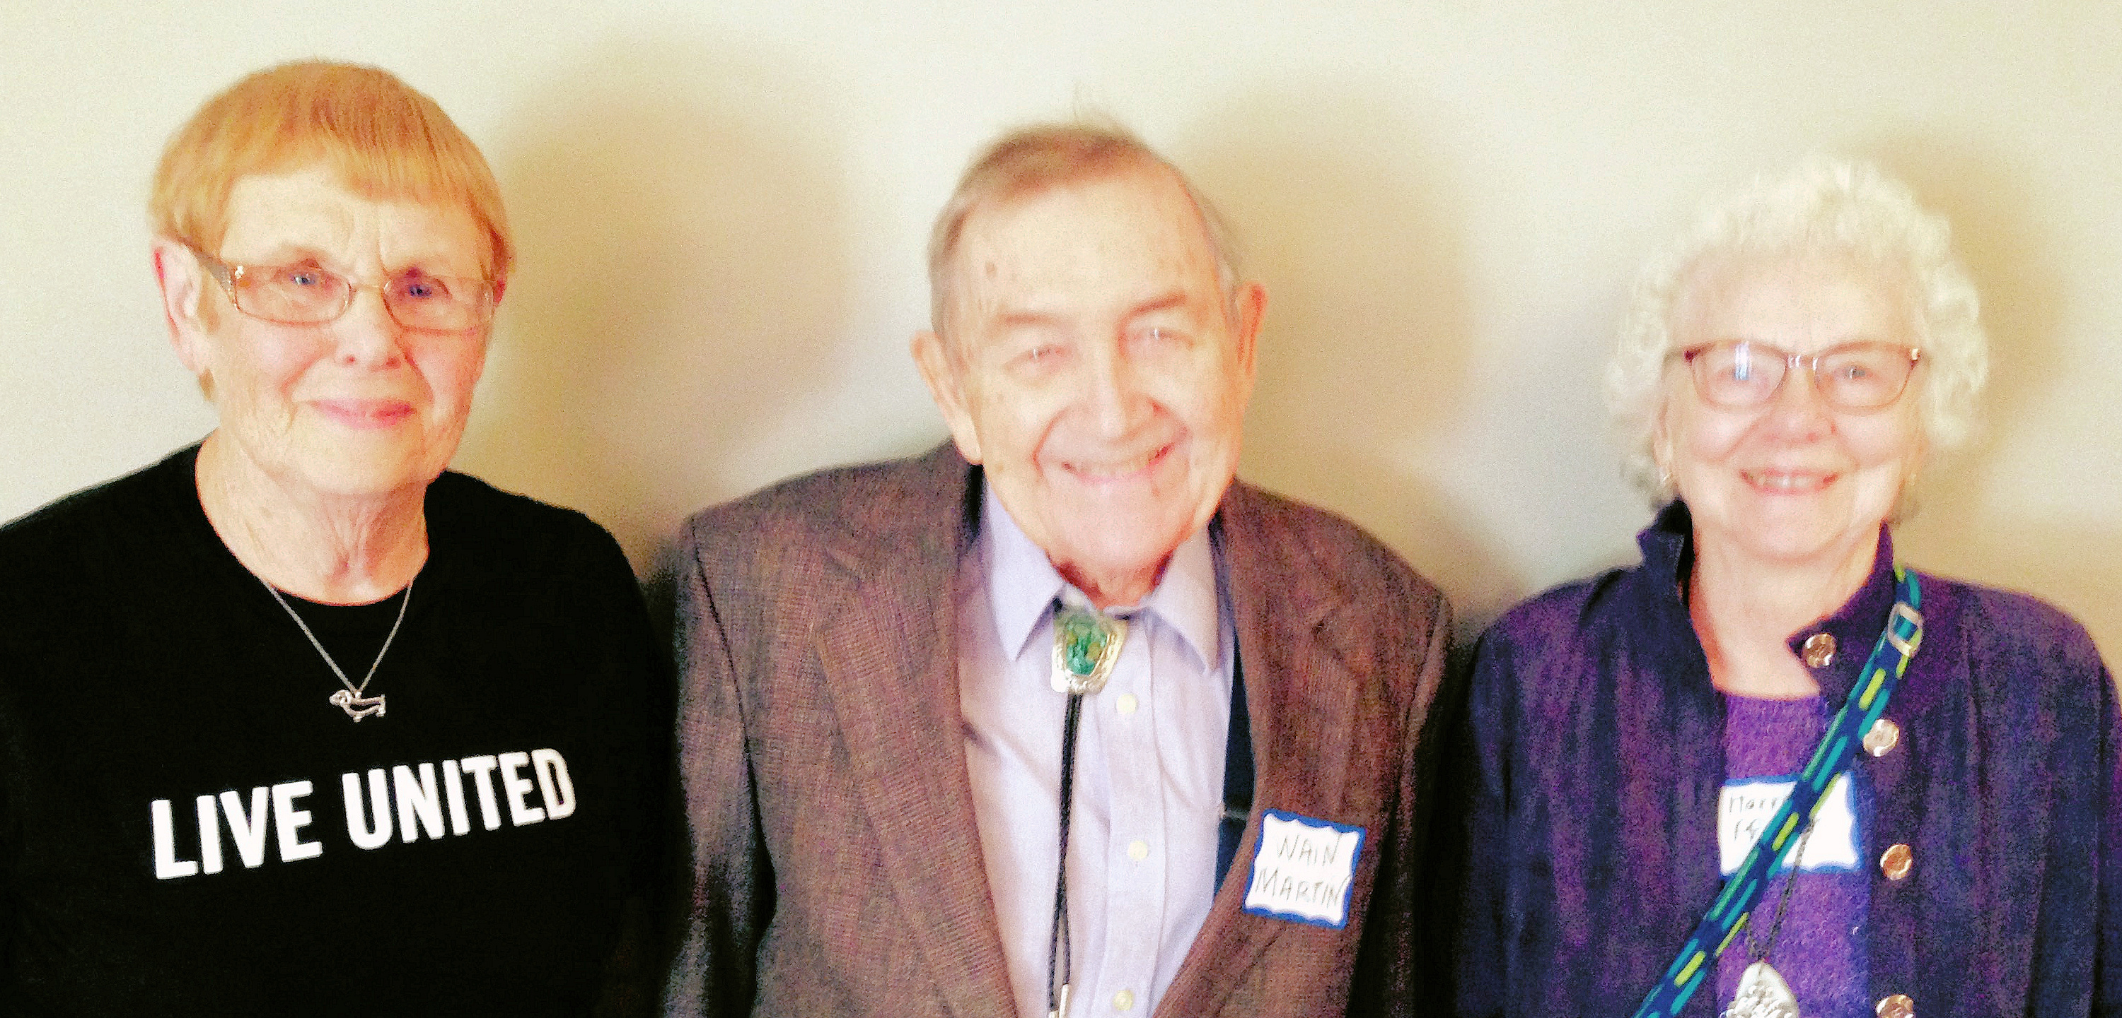**From left, Doris Burton, Wain Martin, Harriet Pfister (2015 photo)**

“We retirees have an awesome record of leadership in the United Way campaign,” Wain writes. Figures support his claim. During the 2016-2017 campaign retirees pledged $188,210, a stunning display of generosity that formed nearly one-quarter of the total individual contributions.

“We CAN continue to make a big difference in people’s lives,” Wain writes in his letter. As we designate “IURA” as our giving unit, we can hear Wain cheering us on: GO RETIREES!

**- - - - - - - - - - - - - - - - - - - - - - - - - - - - - - - - - - - - - - - - - - - - - - - - - - - - - - - - - - - - - - - - - - - - - - - -**

**IU Retirees Association**

**2017-2018 MEMBERSHIP FORM**

Name_______________________________________________________________________

For couple membership, spouse’s/partner’s name____________________________________

Address ____________________________________________________________________

City ____________________________State______9-digit ZIP code____________________

Telephone­* ______________________E-mail* ____________________________________

*Telephone number and e-mail will be included in membership directory only if you write them here.

Enclosed is my check, made payable to IU Retirees Association, for:

__________Single membership ($15) __________Couple membership ($20)

Please mail this form with your check to IU Retirees Association

P.O. Box 8393

Bloomington, IN 47407-8393

____ I wish to receive the newsletter by e-mail rather than in paper form.

**IU Retirees Association Nonprofit Org.**

**P.O. Box 8393 U.S. Postage PAID**

**Bloomington, IN 47407-8393 Bloomington, IN**

**Permit No. 2**

**A peek at coming IURA attractions**

**https://www.exchange.iu.edu/owa/14.2.247.5/themes/resources/clear1x1.gifhttps://www.exchange.iu.edu/owa/14.2.247.5/themes/resources/clear1x1.gif**Here are some dates for your calendar:Thanks you Dick I think that is a good suggestion about listing topics. It may generate some more ideas. Thank you and your cmmittee for getting this going. I'm out of town July 12 until July 19 but am accessible at leat by cell phone 812-325-4348 and infrequently

* Thu 7:37 AM
* Dec. 13, holiday luncheon with Music Warehouse show choir from Edgewood High School

### Jan. 10 at 2 p.m., Matt Bailey, president, IU Health South Central Region, update on IU Health Bloomington Hospital

* Feb. 14 at 2 p.m., TBA
* April 11 at 2 p.m., physicist **Ben Brabson** on climate change
* May 9 at 5 p.m., dinner at Meadowood, with **Charlie Jesseph**, guitar

Ifkiesling

Thanks you Dick I think that is a good suggestion about listing topics. It may generate some more ideas. Thank you and your cmmittee for getting this going. I'm out of town July 12 until July 19 but am accessible at leat by cell phone 812-325-4348 and infrequently

Thu 7:37 AM

**Why am I getting this newsletter?**

You are getting this newsletter for one of two reasons. Database manager **Doris Wittenburg** maintains a Big List with more than 990 names:

1. IURA members pay the costs of printing and mailing *Newswatch* in hopes that others will join (see form on reverse side). Members who have signed up for email delivery are receiving a printed copy while the email list is being developed.

2. Prospective members who do not join or renew their membership will receive the newsletter through November.

If you have not paid dues for this year, this is your next-to-last newsletter. You can check your membership status on your address label.

“2017 DUES PAID--THANK YOU!” indicates you are one of the IURA’s 316 current members –130 singles and 93 couples.

“PLEASE RENEW FOR 2017” means you have been a member in the past but have not yet renewed.

“PLEASE JOIN FOR 2017” indicates you are not a recent member but are invited to join the IURA.

To join, please complete and return the membership form below. If you have signed up for email delivery, this is your final printed copy. If you wish to correct your address or remove your name from the list, send a message to Doris at [dwittenb@indiana.edu](mailto:dwittenb@indiana.edu)with “unsubscribe” in the subject line and your name as it appears on IU records.

**Judy Schroeder** edits *Newswatch* eight times a year, August through April, except for February. Please send corrections and comments to her at [jschroed@indiana.edu](mailto:jschroed@indiana.edu).