NEWSWATCH



**Vol. 2017-2018 No. 8 April 2018**

**________________________________________________________________________________­­­­­­__**

**Next meeting: 5 p.m., Wednesday, May 9 (reservations by May 3 required)**

**Meadowood Retirement Community, 2455 N. Tamarack Trail**

**Celebrate merry May at Meadowood**

Little-known fact: With the encouragement of Herman B Wells, the IU Annuitants Association, the precursor of the IURA, founded Meadowood Retirement Community. The IU Retirees Association will affirm its heritage when members gather at Meadowood on May 9 for the last meeting of the academic year.

From 5 p.m. to 6 p.m., the Meadowood shuttle will bring retirees from the Cyclotron lot, where all have permission to park. A social hour in the Founders Room will feature wine and cheese**.** Meadowood Executive Director **Larry Diersing** and Director of Sales and Marketing **Kathy Norris** will greet us. At 6 p.m. we will move to the Terrace Room for a buffet. Diners can choose from pork tenderloin with bourbon apple chutney, pecan tilapia, veggie lasagna, sweet potato tzimmes, and asparagus. After dinner, mousse in chocolate cups will be served at the tables.

Meadowood is partially underwriting the dinner, but reservations and prepayment of a nominal $10 per person is required by May 3. (See form in this newsletter.) Guests are welcome, but seating is limited to 120.

Diners will be treated after dinner to cello music by **SeungAh Hong**, first-prize winner of the 2018 Indianapolis Matinee Musicale Competition and the 2017 Kuttner Quartet Competition. Ms. Hong is pursuing an Artist Diploma at the Jacobs School of Music, where she has been a student of Peter Stumpf since 2014. A graduate of Korea National University of the Arts, she is the principal cellist of the Columbus (Ind.) Philharmonic and the cellist with IU’s in residence Kuttner Quartet.

**Retirees help IU surpass United Way goal**

As of April 9, retirees had reached a lofty 122 percent of their $210,000 goal for United Way, IURA liaison **Harriet Pfister** announced. Because of 217 generous donors, the IURA pledged $255,955, helping IU to surpass its $815,000 goal. “Retiree giving represents a big chunk of IU’s $830,000,” Harriet said.

**Climate: it is a-changin’, Brabson says**

“The warming of the climate system is unequivocal.” **Ben Brabson** began his discussion of climate change at the April 11 meeting of the IURA with this strong statement from the Intergovernmental Panel on Climate Change. The planet is heating up because of the greenhouse effect.

“The atmospheric concentrations of greenhouse gases -- carbon dioxide, methane, and nitrous oxide -- have increased to levels unprecedented in the last 800,000 years,” Ben said. Ninety percent of the increased carbon dioxide comes from burning fossil fuel, with about 10 percent from changes in land use (deforestation).

Sea levels are rising because of warmer temperatures. “This rise in sea levels may not be a concern for people in Indiana,” Ben said, “but it’s a serious problem in the Maldives and Bangladesh, and it affects everyone living along U.S. coastlines.” Temperatures in Indiana have gone up a tenth of a degree every 10 years for the last 120 years, he said, pointing out that the state’s two major crops, corn and soybeans, are sensitive to higher temperatures.

Under the Trump administration, the U.S. response to climate change has changed radically, Ben said. He compared the EPA website before and after January 2017 to highlight the change. First of all, climate change, which used to have top billing, has been replaced by “revising emission standards.” When you finally reach “climate change,” which is now buried five sections deep, you find the entry “This page is being updated.”

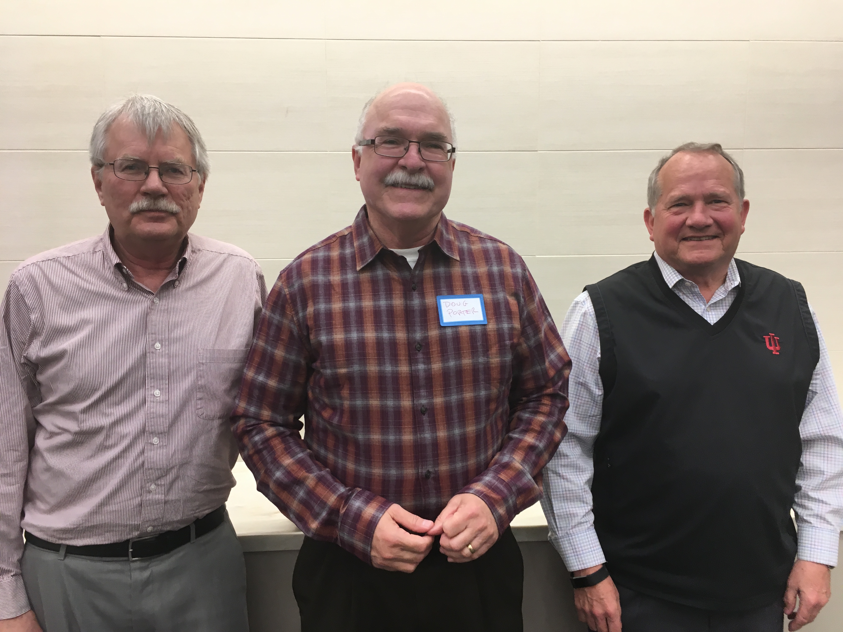EPA Administrator Scott Pruitt is consistently removing scientists from science advisory panels and replacing them with people from industries affected by EPA decisions. He has reinterpreted the Clean Power Plan, which established state-by-state targets for carbon emission reductions while offering a flexible framework under which states could meet the targets. “Pruitt has decided that the system of emission reduction must be limited to a set of measures implementable by the sources themselves,” Ben said. Furthermore, the Trump administration has submitted formal notice that the U.S. is withdrawing from the Paris Climate Accord.

Despite the headwinds, U.S. industry *is* addressing climate change. Indiana, for example, has more jobs in renewable energy than in coal production. Vectren is building a huge solar field in southern Indiana. Solar attic fans are built in Indiana.

Other countries are looking at innovative solutions. The Netherlands has an experimental solar bike path, German and Dutch companies are marketing solar-powered cars, an Indian company is developing a small car powered by compressed air, and a village in Canada has found a way to store solar energy underground during the summer and use it for 97 percent of its heat in winter.

In spirited discussion after Ben’s presentation, the more than 65 retirees in attendance came up with their own innovative questions, insights, and solutions. When **George Dreher** asked when Miami will become uninhabitable, Ben said, “With sea levels rising a couple of inches a decade and increasing damage from every hurricane, people who live along the coast may start paying attention before the rest of us.” Economists have supported pollution taxes since the 1920s, **Lloyd Orr** said. Lloyd pointed out that in Indiana, where electricity is generated mostly by coal, his hybrid vehicle produces less CO2 than an electric car. **Charlie Matson** pointed out that natural gas is a “short-term bridging fuel, with a combined cycle that is twice as efficient as coal.” **Allan Edmonds** wondered whether solar airplanes could make retiree travel more guilt-free.

In introducing Ben, professor of the physics of climate change since 1996, **Harold Ogren** described him as “one of the most optimistic people I know.” Ben made it clear he is pinning a great deal of hope on new ideas from young people and technology.

**Hustad applauds membership growth**

At the annual meeting of the IURA, held April 11, Treasurer **Tom Hustad** announced that dues income had increased by $252. “That means,” Tom said, “that membership has increased. That means that more people recognize the importance of the IURA as a major conduit of communication with the university.” Tom encouraged retirees to consider giving a gift membership in the IURA to a friend or retiring colleague, for celebration and appreciation.

**Elected to serve three years on the IURA board are, from left, Charlie Matson, Doug Porter, and Steve Hitzeman.**

**Remembering our friends**

***Twice a year since 2008, in the April and August issues,* Newswatch *memorializes members who have died since the last listing. Because of space limitations, only IURA members can be included. Please notify me (***[*jschroed@indiana.edu*](mailto:jschroed@indiana.edu)***, 812-332-5057) of any omissions. Thank you.***

***Judy Schroeder,* Newswatch *Editor***

**Eva Dessau Bernhardt-Kabisch died Aug. 23, 2017, in Bloomington. She was 91. Born in Wiesbaden, Germany, the daughter of noted composer Paul Dessau, she moved with her family to escape Nazi persecution, first to Paris and then to the U.S. She moved to Bloomington in 1962 and, when her youngest child started school, she enrolled at IU, earning a bachelor’s degree with highest distinction in 1973 and a master’s in 1978. She earned her Ph.D. in Germanic studies in 1985. She taught introductory German classes at IU and served as an administrative**

**assistant. She enjoyed spending several months in Germany each year. Eva was a passionate lover of theater and music, especially opera. She is survived**

**RESERVATION FOR MAY 9 DINNER**

Shuttle/reception begin at 5 p.m., buffet at 6 p.m.

Meadowood Retirement Community, 2455 N. Tamarack Trail

Name(s) _______________________________________________________________________

______________________________________________________________________________

Indicate special dietary needs_______________________________________________________

Cost is $10 for each meal. Please mail this form with your check to

IU Retirees Association

P.O. Box 8393

Bloomington, IN 47407-8393

**RESERVATIONS AND PAYMENT MUST BE RECEIVED BY NO LATER THAN MAY 3.**

- - - - - - - - - - - - - - - - - - - - - - - - - - - - - - - - - - - - - - - - - - - - - - - - - - - - - - - - - - - - - - - - - - - - - - - - - - - - - -

**by her husband of nearly 61 years, Ernest, professor emeritus of English and comparative literature.**

**Louise Baumbach Brown died May 7, 2017, in Bloomington. She was 70. She was born in Indianapolis and earned her bachelor’s degree at IUPUI in 1978. For many years she worked at the Indiana Business Research Center at the IU School of Business. She was the retired operations director of the Karl F. Schuessler Institute for Social Research in IU’s sociology department. She lived in Nashville and in retirement volunteered at the Brown County Public Library.**

### John Brown Droste died Feb. 5 in Bloomington. He was 90. Born in Hillsboro, Ill., he served in the U.S. Army during World War II. He earned bachelor’s, master’s, and Ph.D. degrees in geology at the University of Illinois. He joined the geology faculty at IU in 1957, retiring in 1992. His “Course Guide for Geology” had widespread use, and he published several books on stratigraphy in Indiana. His atlas of paleogeography of the southern Great Lakes area appeared in 1983. Thousands of students took his G100 course. In retirement John spent hours interpreting well logs, which record electrical and radiation characteristics of the rocks through which a well has been drilled, archived at the Indiana Geologic Survey. John was a woodsman and naturalist and active with the Boy Scouts of America, which awarded him the Silver Beaver and the Order of the Arrow. Mary, his wife of 66 years, survives.

**Bruce Alan Frye died June 11, 2017, in Bloomington, his birthplace. He was 66. Bruce worked as a mechanic, welder, and fabricator. In 2004 he became a machinist for the IU chemistry department, creating custom research equipment. He had a lifelong passion for building and creating. He enjoyed restoring tractors and antique railway cars. He is survived by his wife of 38 years, Barbara, retired assistant undergraduate recorder in the School of Education.**

**Gaynell Hiday Hall died March 15 in Everett, Wash. She was 90. Gaynell was a homemaker. She worked with the Bloomington Hospital Auxiliary for more than 40 years and volunteered for Meals on Wheels for more than 30 years. She was a longtime member of First United Methodist Church. After 56 years in Bloomington, the Halls moved to Everett, Wash., in 2010. Gaynell is survived by Dale, her husband of 70 years, IU associate director of computer services until his retirement in 1990. Dale was secretary and newsletter editor of the Annuitants Association, precursor to the IURA, from 1994 to 1997 and directory publisher from 1997 to 2007.**

**Jane Pennell McIntosh died March 25 in Bloomington. She was 84. Born in Fort Wayne, Jane earned bachelor’s and master’s degrees from IU. She worked first for the Bloomington Parks and Recreation Department and then became an IU academic adviser. She was a member of Chi Omega, Psi Iota Xi, Pi Lambda Theta, Delta Kappa Gamma, PEO, the DAR, and First Christian Church. She was a strong supporter of the arts and served on the board of the Theatre Circle from 1997 to 2003. Along with her husband, she was an active member of the University Club. Jerry, her husband of 63 years, preceded her in death.**

**Jerry Allen McIntosh died Feb. 19 in Bloomington. He was 83. Born in Mount Carmel, Ill., Jerry earned B.S., M.S., and Ed.D. degrees from IU. After first teaching mathematics at University High School in**

**IU Retirees Association Nonprofit Org.**

**P.O. Box 8393 U.S. Postage PAID**

**Bloomington, IN 47407-8393 Bloomington, IN**

**Permit No. 2**

**Bloomington, Jerry joined the School of Education faculty in 1958, retiring in 1998. He was twice president of the Indiana Council of Teachers of Mathematics and served on several committees of the National Council of Teachers of Mathematics. From 2002 to 2005 Jerry was on the board of the IU Annuitants Association, the precursor to the IURA, and was president during 2003-2004. He served on the Theatre Circle board from 2007 to 2010. Jane, Jerry’s wife of 63 years, died less than five weeks after him.**

**Geneva Gibson Burt Spencer McQuigg died Feb. 5 in Bloomington. She was 90. She was born in Kosciusko County, Indiana. With degrees from Manchester College and IU, Geneva taught elementary school in Bloomington, primarily at University School. She was a member of Pi Lambda Theta, an education honor society, and a longtime member of St. Mark’s United Methodist Church. Her husband Bruce, professor emeritus of education and a former president of the IU Annuitants Association (precursor to the IURA), died in 2008.**

**Larry S. Shaver died May 29, 2017, in Bedford, his birthplace. He was 74. Larry studied at IU and the University of Virginia and graduated from the FBI National Academy in Quantico, Va. He served in the communications intelligence branch of the U.S. Air Force from 1962 to 1966. In 1987 he retired from the Bedford Police Department after a 21-year career. In 2013 he retired after 25 years at IU as associate director of risk management. For more than 50 years Larry was active in the Benevolent and Protective Order of Elks, serving as state president and a member of the board of grand trustees. He was a member of the American Legion and of the Fraternal Order of Police. He was a Sagamore of the Wabash and a Kentucky Colonel. Carolyn, his wife of 48 years, survives.**

**Saundra Barrett Taylor died Feb. 17 in Bloom-ington. She was 73. A native of Lexington, Ky., she earned a bachelor’s and a master’s degree in European history at UCLA, where she also received a master’s degree in library science. Once assistant university archivist at UCLA, she became curator of manuscripts and head of the manuscripts department at the Lilly Library in 1975. She also taught in the School of Library and Information Science. Saundra was a world traveler and an avid supporter of IU football and basketball. She loved theater and served as president of the Faculty Drama Club and a board member of the Bloomington Playwrights Project. A board member of the Monroe County History Center, she volunteered at the Kinsey Library. For her service on the advisory boards of the Indiana Archives and Manuscripts Survey, the Lew Wallace Papers Project of the Indiana Historical Society, the Indiana State Library and Historical Board, and the Indiana board of the National Historical Publications and Records Commission, she was named a Sagamore of the Wabash.**

**Do you have your Crimson Card?**

IU has switched to a university-wide ID card, called the Crimson Card, for all students, staff, and retirees. Although old cards still can be used, “I suspect that by the beginning of the next school year, your old ID won’t work,” IURA Benefits Chair **Bruce Jaffee** told retirees at the April 11 meeting.

“Bring your old ID card to either the ground floor of the IMU near the bowling alley or the main floor of the Wells Library (UITS section). You will even get a new picture,” he added.

**About this newsletter**

*Newswatch* is published eight times each year, August through April, except for February. This is the last issue of the 2017-18 academic year. Send corrections or comments to **Judy Schroeder** at [jschroed@indiana.edu](mailto:jschroed@indiana.edu). To correct your address, please contact database manager **Doris Wittenburg**, [dwittenb@indiana.edu](mailto:dwittenb@indiana.edu)*.*