NEWSWATCH
Vol. 2015-2016 No. 3 October 2015
_________________________________________________________________________________

Next meeting: Media Then and Now, 2 p.m., Wednesday, November 11
Peterson Room, Showalter House, IU Foundation, SR46 Bypass

Founding dean of Media School to speak

Jim Shanahan, founding dean of IU’s Media School, will talk to retirees on Nov. 11 about “The Media We Knew and the Media School.” The program will be in the Peterson Room at the IU Foundation at 2 p.m.

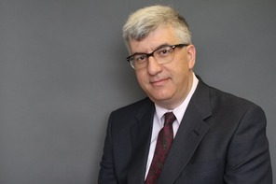 “Media are converging in ways that are often difficult to keep up with," Shanahan said in a January interview with the Chronicle of Higher Education. The lines between media roles, he said, “are becoming more and more permeable.” Media education needs to reflect this change and make students comfortable with a multimedia approach.

The Media School combines the former School of Journalism, the telecommunications department, and parts of the communications and culture department. It officially came into existence on July 1, 2014. In December 2014 Shanahan’s selection was announced, and he began his duties May 1, 2015.

Shanahan was professor and associate dean of the College of Communication at Boston University. Previously he was chairman of the communication department and director of graduate programs at Fairfield University and spent more than a decade as a professor in the Department of Communication at Cornell University. He received his Ph.D. in communication from University of Massachusetts at Amherst.
Panelists to discuss caregiver challenges at November community event

Whether as a child, sibling, or spouse, retirees suddenly can become caregivers. On Saturday, Nov. 7, the community and family resources department of the City of Bloomington will sponsor an event for caregivers. Titled “Navigating the Caregiver Challenge,” the event will bring together community members to discuss the challenges and questions associated with care-giving.

People who have experienced care-giving firsthand will suggest resources and discuss ways people can support each other. One panelist will be IURA member Howard Mehlinger, who says, “Caring for an Alzheimer’s patient at home is full-time work, and I soon realized that I would need help. Friends, neighbors, and children did whatever I asked, but I found the specialized help I needed through the Alzheimer’s Resource Service, a community health program sponsored by the IU Health Bloomington Hospital.”

Other panelists include Mike Gentile, Doug Grant, Marsha McCarty, Janna Robson, Wendy Rubin, Susan Sandberg, Jaime Sweaney, and Charlotte Zietlow. Each panel will be from 65 to 70 minutes in length, with 15-minute breaks between sessions. The approximate schedule:
9:10 a.m. Alzheimer’s/dementia
10:30 a.m. Caregiver burnout/self-care
11:45 a.m. Pre-planning.

The event is from 9 a.m. to 1 p.m. in the City of Bloomington Showers Building Atrium and Council Chambers, 401 N. Morton St. Attendance is free, but please RSVP at http://tinyurl.com/caregiverchallenge.
United Way drawing gives two free lunch

From left, Doris Burton, Wain Martin, and Harriet Pfister form the IURA’s United Way leadership team.

Retirees whose 2015 United Way campaign pledge is received by Nov. 7 will have their names entered in a drawing. The winner will receive two free reservations for the Dec. 9 IURA holiday luncheon featuring the African American Choral Ensemble. Doris Burton, part of the IURA’s United Way team, said Andy Mohr, the speaker at the UW kickoff breakfast, inspired this innovation by advising, “Start fast and offer incentives.”

Even without incentives, Harriet Pfister announced, retirees are well on their way to achieving their lofty goal of $145,000. As of Oct. 13, 45 donors had pledged $45,877 – about 32 percent of the goal. Wain Martin, the third member of the IURA leadership team, says, “We retirees are incredibly civic-minded and generous. GO RETIREES!”

On Oct. 14 Newswatch interviewed the UW team.

How do you answer people who say United Way is superfluous because each agency collects money on its own anyway?

A: The United Way doesn’t provide 100 percent of any agency’s budget, but it does help agencies interact and collaborate. It also offers technical assistance. Organizations are vetted before they can become official UW agencies. They have to fill out a long questionnaire and meet certain requirements.

Do you have a favorite among the agencies?

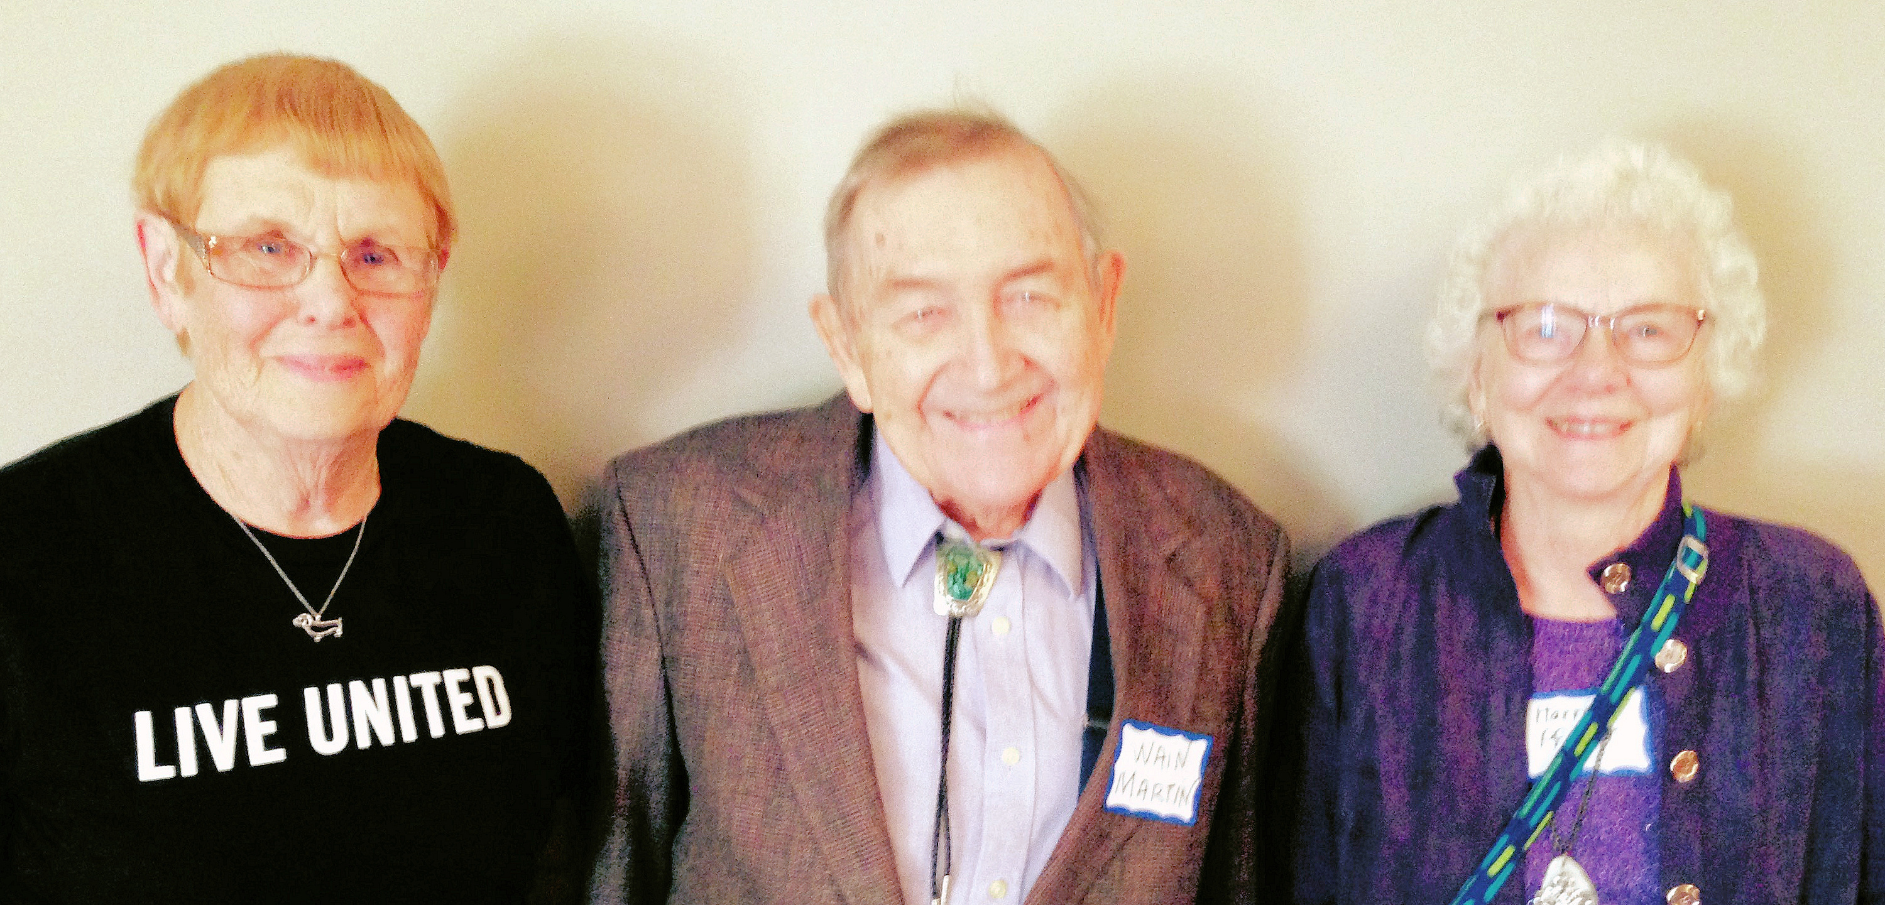As a longtime United Way liaison to Planned Parenthood, Harriet says, “I know and support that embattled agency.” Doris point outs, “Some UW agencies are organizations we wouldn’t think of, but they do important work even if they don’t have a high profile.”

Why are you willing to take on this responsibility every year?

“Some people in our community desperately need help,” Wain says. “Many dedicated social service agencies provide a much needed safety net, but every year these agencies struggle to obtain the funding to continue to provide services. United Way is a community treasure that provides much needed financial support for many of the most effective of these organizations.”

Harriet adds, “I am amazed every year by the way retirees come through.” Doris points out that the IURA contributes an impressive 10 percent of the United Way’s total goal. “When you return your pledge, be sure to designate the IURA as your giving unit,” she reminds retirees.

College athletics in crisis: Kurt Zorn explains NCAA, Big Ten, and Power 5

College athletics is big business, and the NCAA is responding to the changing landscape of Division I intercollegiate athletics. That was the message IU faculty athletics representative Kurt Zorn brought to an SRO crowd of nearly 60 retirees on Oct. 14 when the IURA met at the DeVault Alumni Center.

In 2014 the NCAA had income of about $989 million, $750 million from TV and marketing. Nearly $550 million of that amount was distributed to Division I schools. In 2015 March Madness revenues were more than 500 percent higher than they were two decades ago. “Figures like that,” Kurt said, “make for a lively ongoing discourse in political and policymaking circles as well as in the courts.”

Attitudes toward college athletics are changing rapidly. In a Seton Hall survey, 38 percent of respondents in 2015 support paying salaries to college athletes who play revenue-generating sports, up from 29 percent in 2014.

Kurt cited other figures from the survey:
- 52 percent support providing medical benefits after graduation.
- 47 percent support giving student athletes spending money.

- 54 percent support free post-graduate education.

When people talk about money and college athletics, Kurt said, they are talking about the Power 5 conferences: the Big Ten, ACC, Big 12, PAC-12, and SEC. The Power 5 has only 65 schools. Kurt pointed out that, out of 130 public schools, only 24 – including IU – have athletics departments that are self-sufficient. Division I comprises very different types of institutions, and in the past smaller schools blocked changes proposed by conferences that have resources to provide more to student athletes.

In 2014, in response to increasing pressure, the NCAA gave the Power 5 the authority to create its own rules for student well-being. Among the changes the Power 5 adopted in January:
- Student athletes may receive stipends to cover the actual cost of attendance that scholarships do not cover.
- Schools may not revoke scholarships based on athletic performance.
- Student athletes may borrow against future earnings to buy loss-of-value insurance.
- A concussion safety protocol was established, with a committee to review and supervise the NCAA’s new concussion safety guidelines. Dr. Brian Hainline, the NCAA’s chief medical officer, says he hopes these guidelines may become NCAA legislation at some point.

Litigation began when Ed O’Bannon, a former UCLA basketball player, sued the NCAA in 2009 under the Sherman Antitrust Act. “O’Bannon v. NCAA is just the opening salvo,” Kurt said. “Litigation will continue for some time because the NCAA has lots of money and the United States has lots of lawyers.”

The difficulty with paying players, Kurt said, is that student athletes would be treated as professionals. “It would be the end of college sports as we know it,” he said. The revenue that supports nonrevenue sports would be reduced dramatically, and the implications for Title IX and women’s sports are tremendous.

While waiting to ask Kurt questions, retirees sampled the delicious cookies provided by Jo Anne Bowen,
Doris Burton, and Doris Fox.

University Club, Emeriti House programs

Many IURA members participate in the programs of our partner organizations, the Emeriti House and University Club. For information on these organizations, see:
www.indiana.edu/~emeriti and
www.indiana.edu/~uclub

- - - - - - - - - - - - - - - - - - - - - - - - - - - - - - - - - - - - - - - - - - - - - - - - - - - - - - - - - - - - - - - - - - - - - - - -

IU Retirees Association
2015-2016 MEMBERSHIP FORM

Name_______________________________________________________________________

For couple membership, spouse’s/partner’s name____________________________________

Address ____________________________________________________________________

City ____________________________State______9-digit ZIP code____________________

Telephone* ______________________E-mail* ____________________________________
*Telephone number and e-mail will be included in membership directory only if you write them here.

Enclosed is my check, made payable to IU Retirees Association, for:

__________Single membership ($15) __________Couple membership ($20)

Please mail this form with your check to IU Retirees Association
P.O. Box 8393
Bloomington, IN 47407-8393
____ I wish to receive the newsletter by e-mail rather than in paper form.

IU Retirees Association Nonprofit Org.
P.O. Box 8393 U.S. Postage PAID
Bloomington, IN 47407-8393 Bloomington, IN
Permit No. 2

December holiday luncheon to feature African American Choral Ensemble

The annual IURA holiday luncheon will feature members of the African American Choral Ensemble. The luncheon will be Dec. 9 in the Grand Hall of the Neal-Marshall Black Culture Center, 275 N. Jordan Ave. Parking will be available across the street in the Jordan Avenue garage. Look for more details and a reservation form in the November newsletter.

Get questions answered at benefits fair!

University Human Resources will sponsor a Benefits Fair on Tuesday, Nov. 10, from 9 a.m. to 3 p.m. in Alumni Hall of the Indiana Memorial Union. The “things to do” list includes:
- Learn about investing in IU Retirement plans
- Ask questions about your medical plan and get help enrolling
- Attend an Open Enrollment education session at the Whittenberger Auditorium
- Get your annual flu shot
- Enter a drawing for prizes donated by numerous vendors.
The fair offers an opportunity to discover campus and community resources that support yhealth and wellness. For more information, go to http://hr.iu.edu/benefits/fair/

Volunteers sought to prepare taxes

The United Way of Monroe County and the Free Community Tax Service need volunteer tax preparers to serve at sites in Monroe and Owen counties. In January volunteers will receive training – about 10 hours’ worth – in income tax law and tax preparation to become IRS-certified. From January to April FCTS provides free federal and state income tax preparation to low- and moderate-income residents. Hours are flexible, but volunteers are encouraged to work at least three hours a week.

After completing one year of service as a tax preparer, volunteers are eligible to become site coordinators. For more information, call Sarah Taylor at 812-3334-8370.

Why am I getting this newsletter?

You are receiving this newsletter for one of three reasons. Database manager Doris Wittenburg maintains a Big List with more than 1,000 names:

1. IURA members pay the costs of printing and mailing Newswatch in hopes that others will join the IURA (see form on reverse side).
2. The 110 people whom Human Resources identified as having retired during the last year will be mailed the newsletter during this academic year.
3. People with paid membership in 2013 or 2014 will receive the newsletter through November. After that they will be dropped if they do not renew.

Judy Schroeder writes Newswatch eight times a year. Please send corrections and comments to her at jschroed@indiana.edu. To remove your name from the list, send a message to dwittenb@indiana.edu with “unsubscribe” in the subject line and your name as it appears on IU records.

