NEWSWATCH



**Vol. 2016-17 No. 5 December 2016**

**________________________________________________________________________________­­­­­­__**

**Next meeting: 2 p.m., Wednesday, January 11, 2017**

**Peterson Room, Showalter House, IU Foundation, SR46 Bypass**

**Museum director Brenneman to describe changes to 75-year-old university icon**

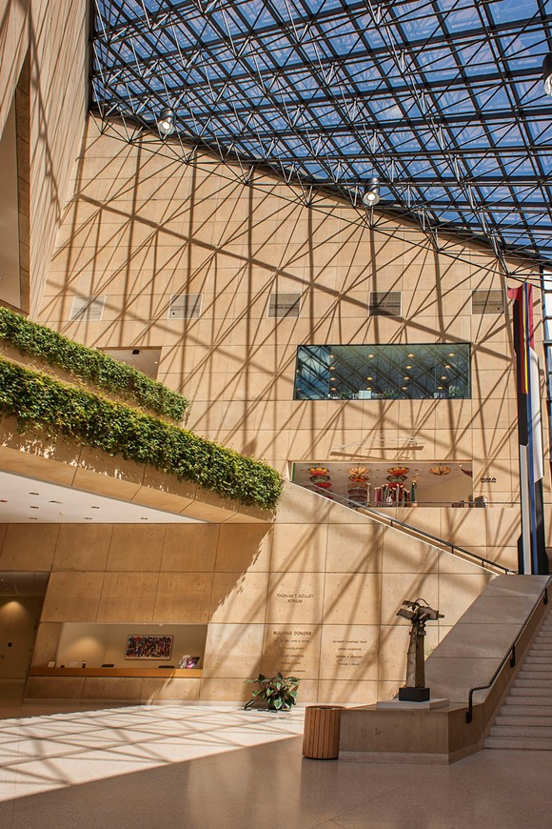“There’ll be some changes made.” That will be the theme when retirees gather on Jan. 11 at 2 p.m. to hear **David A. Brenneman** describe the changes coming to IU’s iconic art museum. He will describe the $20 million metamorphosis that will require the museum’s closing from May 2017 to spring 2020.

Brenneman was appointed Wilma E. Kelley director of the museum in July 2015. In May 2016 the museum transmogrified into the Eskenazi Museum of Art, to honor the $15 million contribution of Indianapolis-based philanthropists Sidney and Lois Eskenazi.

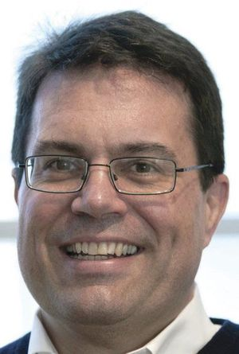Before coming to IU, Brenneman spent 13 years as a senior administrator at the High Museum of Art in Atlanta. As director of collections and exhibitions at the High Museum, he led the curatorial team that planned the renovation of the building and the installation of new galleries. At IU he succeeded Heidi Gealt, who retired after nearly 30 years at the museum’s helm.

He received his Ph.D. in art history from Brown University and graduated from the Getty Museum Leadership Institute in 2004. He received the Chevalier de l'Ordre des Arts et des Lettres from the French government in 2008.

IU’s art museum opened in 1941 under the direction of Henry Radford Hope. It moved into gallery space in the new Fine Arts building in 1962. I.M. Pei designed the separate building that opened in 1982.

**What’s Up with IU’s Two-Step Login?**

The IU computer systems will require two-step logon to reach secure content starting Feb. 2, 2017. Even if you use the system only to check email or use publicly available information (sports schedules, for example), you should sign up so you will have access when you need to use a resource that requires logon through CAS (Central Authentication Service), such as:

* IU Benefits
* Parking Operations
* Library services such as requesting book delivery or renewal
* Library leased databases.

Here’s how Two-Step works: When you connect through CAS, UITS will call you (by phone) or send a message to your cell phone or tablet. You confirm that you are actually you and using UITS by pressing a button on the phone or screen and then continue to log on.

UITS needs to know how to reach you to send the message for confirmation. You tell them which phone number and device to use and download an app if you’re using a smartphone or tablet. For information on how to tell them which device(s) can reach you as well as other options, go to <https://kb.iu.edu/d/bfgm>.

UITS experts on Two-Step are available at the Wells Library walk-up desk, workdays until 9 p.m. and also on weekends. Other times and locations to work with the experts are at

<https://itnews.iu.edu/events/face-to-face-support-for-two-step-login.php>. Or you can call the general UITS helpline at (812) 855-6789.

Tech experts will be on hand following the Jan. 11 IURA meeting. Bring your IU ID and your cell phone or tablet to get help with Two-Step!

*--Ralf Shaw*

**Holiday luncheon features sweaters, poinsettias, Singing Hoosiers**

“Charming and fun”: That’s how one retiree described the array of Christmas sweaters that brought beauty, humor, and color to the IURA holiday luncheon Dec. 14 at the IU Foundation. It may have been freezing outside, but nearly 90 retirees and friends enjoyed the warm atmosphere and tasty buffet before being entertained by about 35 exuberant Singing Hoosiers.



Among the singers were two granddaughters of IURA members: Arielle Moir, granddaughter of **Lou Moir**, and, pictured above, Audie Deinlein, granddaughter of **Sue Talbot**.

Energetic director **Ly Wilder** led the group in songs new and familiar, including a jazz version of “We Three Kings.” The young singers then fanned out among the tables to encourage retirees to join in bringing Santa Claus to town.

Past IURA President **John Hobson** introduced the Singing Hoosiers, describing their annual Chimes of Christmas as “a spectacular production.”

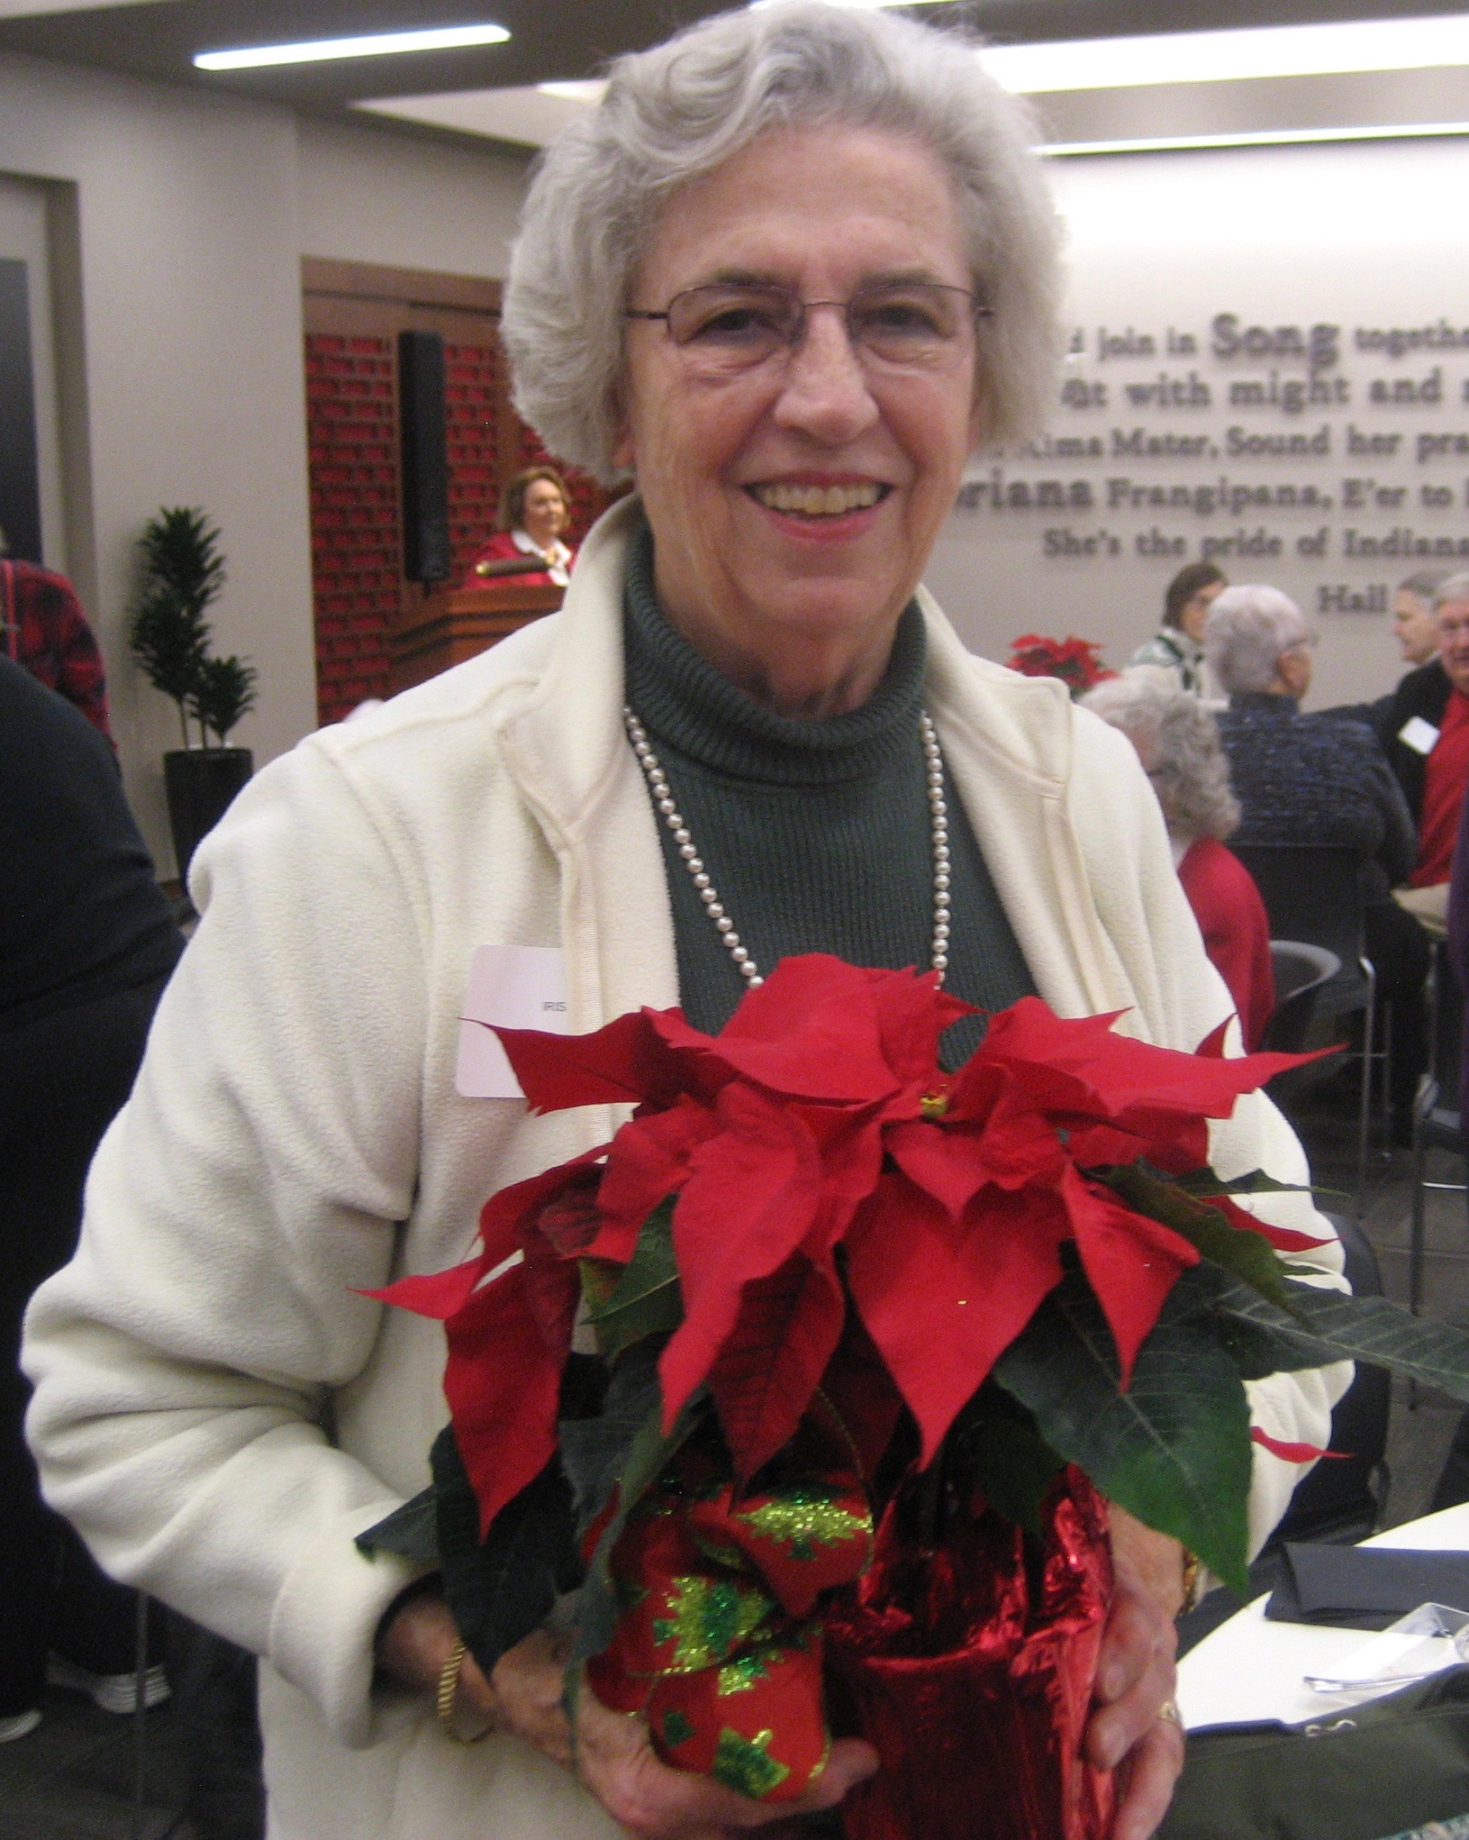IURA President **Joanie Curts** recognized a special honor conferred on **Iris Kiesling**, 2011-12 IURA president. Bloomington Mayor John Hamilton named Dec. 13, her 80th birthday, officially Iris Kiesling Day. Iris was honored for more than 30 years of service to the city and county. After the luncheon Iris was one of the lucky people to go home with a poinsettia.

Hospitality chair **Martha Wailes** arranged the luncheon, assisted by committee members **Mary Ellen Anderson, Suzanne Phillips,** and **Carol Stokes**. More photos are at the IURA website, <http://www.indiana.edu/~iura>.

**United Way: We’re right on track**

“I have every confidence that we’ll make the goal and possibly even exceed it,” **Doris Burton** told retirees at the Dec. 14 holiday luncheon. **Harriet Pfister** announced that the IURA was 85.5 percent of its way toward its lofty United Way goal of $170,000. Of the 175 retiree donors who have pledged $145,382 to date, 67 are Vanguards, contributing $1,000 or more. **Wain** **Martin**, the third member of IURA’s United Way leadership team, conferred the distinction “generous and illustrious” on those assembled.

If you haven’t made your commitment yet, please be sure to specify IU Retirees Association as your giving unit. Historically the amount pledged by IU retirees has made up 10 percent of the total raised by United Way.

**Emeriti House, University Club: Partners**

For information on the programs of the Emeriti House and the University Club, see <http://www.indiana.edu/~emeriti> and <http://www.indiana.edu/~uclub>.

**What will we do with the grandchildren?**

Bloomington can feel like everything has shut down just when grandchildren arrive for the holidays. Here are some ideas for activities for visiting families, to burn off some of that energy.

Did you know you can check out toys at the Monroe County Public Library? The children’s section is fantastic – books, CDs, movies, graphic books, and toys, all for the (temporary) taking, plus play areas. Pre-register for the free magic show in the Auditorium Dec. 29 at 2:30 p.m. At the Children’s Program Room younger children (ages 3-6 with caregiver) are welcome at the preschool dance party Dec. 27 at 10 a.m. and (ages 2-6 with caregiver) for Shake Your New Year’s Sillies Out Dec. 31 at 2:30 p.m. Older children (ages 8-12) are welcome at Radical Fun Dec. 28 at 3 p.m.

Down the street from the library, the Monroe County History Center is open Tuesday through Saturday from 10 a.m. to 4 p.m., with free admission Dec. 27 to 30. It is closed Mondays and Christmas Eve and Day, New Year’s Eve and Day.

WonderLab is open Tuesday through Saturday from 9:30 a.m. to 5 p.m. It is closed Mondays and Dec. 24 and 31. Science Mini Golf is featured Dec. 27-30 from 11:30 a.m. to 3 p.m.

For children age 4 and up, Cardinal Stage’s *Oliver!* is on through Dec. 31.

The IU women's basketball team plays Ohio State at Simon Skjodt Assembly Hall Dec. 31 at 3 p.m.

Frank Southern Ice Skating Center is open except for Dec. 24 and 31. Check for public hours. Skate rental available.

If you are a Y member, check for public swim hours, romp in Cardinal Court, or check out The Zone for ages 7-12. Kids 5-12 can be signed up by the day for holiday camp Dec. 26-30. Check out sports camp and, for ages 7-14, gymnastics camp at <https://www.monroecountyymca.org/content/holiday-camp-registration-open>

A trail around the Tibetan Mongolian Buddhist Cultural Center takes you past or through several of the structures and along a tricky ravine path. Much better known are the path around Winslow Park; the trails at Griffy Lake or in the IU Nature Preserve; the B-Line Trail and Rail Trail.

Within a 45-minute drive west of Bloomington are two surprising attractions:

• The Exotic Feline Rescue Center is closed Mondays but open from 10 a.m. to 5 p.m. other days: <http://www.exoticfelinerescuecenter.org/home.html>

• Sculpture Trails Outdoor Museum <http://www.sculpturetrails.com/>. More than 100 large-scale outdoor sculptures along a mile-plus of trails through the woods. Open seven days a week 10 a.m. to sundown.

Worth a look too (no hike here) is the Tulip Trace Trestle, “2,307 feet long and 157 feet tall, [the] steel-girded railroad trestle is one the longest of this type of bridge in the world still in use today.” [http://www.visitgc.com/where-to-go/innovation/tulip-trestle/ - .WEiAT33FycY](http://www.visitgc.com/where-to-go/innovation/tulip-trestle/#.WEiAT33FycY)

Have a great holiday!

*-- Martha Wailes*

**IU Retirees Association**

**P.O. Box 8393**

**Bloomington, IN 47407-8393**

**Curiosity never retires**

***--Motto of Osher Lifelong Learning Institute***

***University of Nebraska-Lincoln***

**Here’s your membership directory!**

Dues-paying members of the IURA are receiving a membership directory by mail with their December *Newswatch.* **Doris Wittenburg**, IURA database manager, compiled the directory, which contains information on the IURA’s 419 members. Telephone numbers and email addresses appear only for people who included them with their membership form. The directory format differs from previous years but contains the same information.

Because the directory is for members only, it is not being distributed in electronic form. It is being mailed with the newsletter, even to those members who have requested email delivery of *Newswatch*.

To correct your address or to be removed from the list, please contact Doris at [dwittenb@indiana.edu](mailto:dwittenb@indiana.edu). For comments about or corrections to the newsletter, please contact *Newswatch* editor **Judy Schroeder**, [jschroed@indiana.edu](mailto:jschroed@indiana.edu).

**Put these dates on your 2017 calendar**

* Feb. 8 at 2 p.m., Jacobs School of Music’s **Glenn Gass**, on Bob Dylan; cosponsored by Emeriti House
* April 12 at 2 p.m., **Dr. Rob Stone,** medical director of IU Health’s palliative care program
* May 10 at 5 p.m., the annual pitch-in dinner, with **Randy White** of Cardinal Stage

All these meetings are at the IU Foundation. Note that the IURA does not meet in March, and there is no newsletter in February.