NEWSWATCH
Vol. 2015-16 No. 7 March 2016
__________________________________________________________________________________

Next meeting: 2 p.m., Wednesday, April 13
Kelley Dining Room, DeVault Alumni Center, 1000 E. 17th St.

Political scientist Marjorie Hershey
to give her take on 2016 elections
Political scientist Marjorie Hershey will be the guide when retirees take a tour of the strange country known as the Elections of 2016. Margie has titled her topic “Who Will Be the Presidential Candidates? The Results of the Primaries and Caucuses So Far.” The meeting will be in the Kelley Dining Room, DeVault Alumni Center, on Wed., April 13, at 2 p.m. It will also function as the annual meeting of the IU Retirees Association.

Margie, who earned her doctorate at the University of Wisconsin, has taught at IU, in her words, “since the beginning of time” – also known as 1974. Her textbook on political parties is in its 15th edition. National and international media often ask for her comments because she is erudite, enlightening, and entertaining. Margie is the winner of numerous teaching awards, and her annual presentations at Mini University are standing room only.

Parking is available, free of charge, in the lot directly north of the DeVault Alumni Center on 17th Street and on the west side of the building.

Annual meeting to feature board election

At the April 13 meeting, the nominating committee will present three candidates for three-year terms on the IURA board. The candidates are Mary Ellen Anderson, Bill McGregor, and Debora “Ralf” Shaw.

Mary Ellen Anderson, before her retirement in 2013, had 35 years of experience in admissions at IU, the last 15 as director of admissions. Mary Ellen holds two degrees from IU and has served on the Professional Staff Council, the boards of the University Club and the Women’s Faculty Club, and the Residence Life Fellows Program.

Eugene B. “Bill” McGregor Jr. is an emeritus professor in the School of Public and Environmental Affairs. He retired in 2011. Bill is active in the Bloomington Community Band and is on the program committee of the Emeriti House. He enjoys gardening, golf, skiing, his two grandsons, and traveling to interesting places with his wife, Carol.

Debora “Ralf” Shaw received her Ph.D. from IU and returned as a faculty member in the School of Library and Information Science. She served as associate dean and eventually as dean when SLIS merged with the School of Informatics. Ralf retired in 2014 and enjoys occasional research projects, more frequent dog walks, and not looking for parking on campus.

Suzanne Phillips and Doug Porter were the nominating committee. IURA treasurer Don Granbois will present a financial report. Don’s term expires this year, along with that of secretary Jo Anne Bowen and president Jo Daron. Copies of the new HR brochure targeted specifically for IU Bloomington retirees will be available.

Can you host a student from Burma?

IU’s Office of International Development is seeking house hosts for a contingent of high school students from Burma, also known as Myanmar, in April. Two of the four weeks of the students’ visit require a host family experience, from April 16 to 30. Individuals and families who can welcome one or two students into their homes are invited to contact the program manager Courtney Hermann, at
cmherman@indiana.edu, (812) 855-0775.

“Students from past years have been kind, gracious, and eager to learn about culture and lifestyles in the U.S.,” says Courtney, who is arranging for host families. She describes the students as “energetic, inspiring young people witnessing their country emerge from nearly fifty years of isolation.”

Host responsibilities include providing transportation to campus at 9 a.m. for programmed activities, picking up guests after 5 p.m. at the conclusion of their day, offering breakfast and dinner on weekdays and three meals a day on the weekend, and including participants in the normal activities and routine of your household. (Hosts can ask students whether they prefer to call their country Burma or Myanmar.)

During mid- to late summer, Courtney explains, the Office of International Development will be hosting students from Italy. “Families unable to host Burmese students certainly can engage with Italian students in the summer,” she says.

Works sought for Emeriti/IURA art exhibit

Retirees and their spouses or partners are invited to submit art for the annual Emeriti House/IURA annual art exhibit. The organizing committee welcomes submissions in any art medium. Works in a medium that has been underrepresented in the past – collage, woodwork, sculpture in various materials, pottery, and textiles (including weaving, needlepoint, knitting, and embroidery) – are especially welcome.

Works should be submitted at Emeriti House on May 2 between 9 and 11 a.m. Individual contributors may submit from one to three works of art. Art should be submitted ready to be exhibited, ready to be hung if

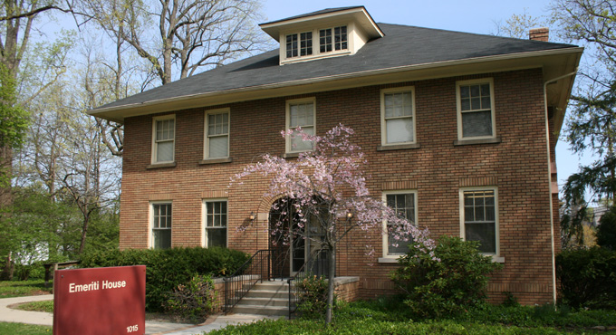

to be shown in that way. A label on the back of the piece should state the name of the submitter; if for sale, the price; if not for sale, “NFS;” the medium; and the title of the piece if there is one. Address questions to Jerry Chertkoff, chertkof@indiana.edu, (812) 855-7910, or B.J. Irvine, irvine@indiana.edu, who co-chair the organizing committee. Other committee members are Dick Dever, Audrey Heller, Ed McEndarfer, Ruth Miller, Bob Talbot, Beau Vallance, and John Woodcock.

The opening reception is Friday, May 6, from 5 to 7 p.m., at Emeriti House, 1015 E. Atwater Ave.
For information about the programs of the Emeriti House, see www.indiana.edu/~emeriti.

May 11 dinner not a potluck this year

On Wednesday, May 11, the IURA celebrates the end of the academic year with a dinner instead of its traditional potluck. Because ongoing renovations at the IU Foundation make it impossible to hold the potluck there, retirees will be guests of Meadowood. After the 5 p.m. social hour and dinner, the folk duo of Greg Buse and Rebecca Keith will perform. Look for more information in the April newsletter.

And then there were ten …

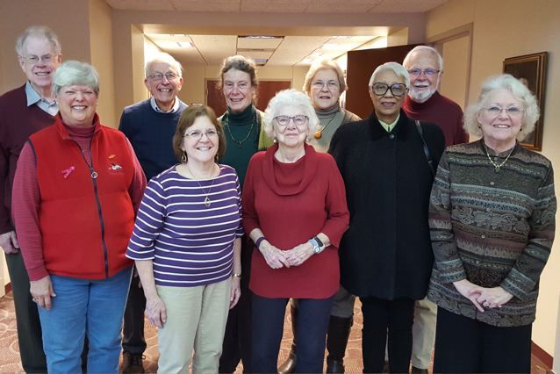IURA board members attending the February board meeting pause for a photo. Front row: board member Suzanne Phillips, secretary Jo Anne Bowen, hospitality chair Harriet Pfister, board member Carol Stokes, and president Jo Daron. Back row: board member Tom Hustad, historian Bob Dodd, board member Martha Wailes, database manager Doris Wittenburg, and treasurer Don Granbois. Not shown: vice president Joan Curts, past president John Hobson, benefits chair Bruce Jaffee, webmaster Suzann Owen, board member Doug Porter, and editor Judy Schroeder.
Biographer of trumpeter believes
marketing, jazz not dissimilar

“As a marketing professor, I was interested in innovations in goods and services,” Tom Hustad told more than 40 retirees who gathered for the Feb. 10 meeting of the IU Retirees Association. “Those innovations are similar to what happens in jazz.”

When Tom received permission from jazz cornetist Reuben “Ruby” Braff to write his biography (Born to Play was published in 2012), Braff told him, “Tom, don’t write about me. Write about my music. I’m an entertainer with a horn in my mouth.”

Tom related how he had come to love jazz as a boy listening to his grandparents’ 78 records. As a student at Purdue, he had a jazz program on student radio. He persuaded Louis Armstrong to do a promo for his program, with Louis declaring, “It puts the swing in Purdue University.” During his first teaching stint at York University in Toronto, Tom had an opportunity to meet Ruby Braff at a club in February 1973. “You taught me taste in music,” Tom told him.

Braff was a brash, unrelenting personality who applied tough standards to himself and others, Tom related. The son of Jewish immigrants from Russia, Braff taught himself to play while listening to the radio. He didn’t learn to read music until the 1960s. Five feet in height, he explained his choice of the cornet by saying, “Short people shouldn’t play long instruments.”

When Braff got his start in Boston, he was so young that part of his pay had to be carfare to the gig. He quickly established a reputation and played with Fats Waller. Bobby Hackett helped him get jobs in New York. Braff commuted from Boston, spending his weekends living with Pee Wee Russell and his wife.

As his fame increased, Braff played at Carnegie Hall and the Newport Jazz Festival. He was paired with Louis Armstrong on a TV special sponsored by Timex. He became a soloist with Benny Goodman for Capitol Records in 1954 and for Basin Street West in 1955. In 1957 he recorded “Hey Lilee Lilee Lo” with Pete Seeger and the Weavers.

In February 1973 he appeared with Tony Bennett on the Mike Douglas Show. When Douglas asked him for one word to describe his style, Braff answered, “Mine.”
Braff enjoyed a long musical career. His first recording was released in December 1949 and his final recording in August 2002. At his death in 2003, he had $23,000 in the bank.

Why write about Braff? Tom answered that question simply: “I don’t want his reputation to die.”

After the meeting, held at the DeVault Center, retirees enjoyed refreshments provided by Rosemary Dever, Gerry Miller, and Martha Smiley.

You had questions about IT benefits?

IURA benefits chair Bruce Jaffee provides the following guideline about IT benefits for retirees.

Retirees from most government and private sector positions lose access to their email accounts and other provided computer services upon their employment separation. IU, however, with some restrictions and benefits, has policies that allow continuation of computer-related benefits on the same basis as for active employees. University Information Technology Services (UITS) has a large number of polices that deal with privacy, security, cost, and vendor relationships. Here is some information of special interest to retirees.

1. Retired IU faculty and staff may continue their email accounts (or get their first ones) until their death. The spouse of a deceased retiree may request a computer account, including email. Upon learning of a death from Human Resources (HR), UITS will deactivate the deceased’s computer account, typically within seven days. Upon request, UITS will provide a deceased retiree’s emails to a spouse on a disc or flash drive. UITS will download the emails but will not sort or read them. As with the policy for students and employees of IU, login information and computer accounts are not to be shared with anyone else, including family and friends.

2. Discounts for equipment (e.g., Dell, Apple, and Sony) are available to retirees on the same basis as for active employees. The same is true for mobile phone services.

3. Retired faculty have access to software covered by Enterprise License Agreements on IUware and IUanyWare. Because of restrictions in agreements with the software vendors, retired staff do not have this benefit.

IU Retirees Association Nonprofit Org.
P.O. Box 8393 U.S. Postage PAID
Bloomington, IN 47407-8393 Bloomington, IN

4. All retirees may register for IT Training workshops and download related materials at no cost. Training materials at Lynda.com are free for retired faculty, but retired staff will be charged standard rates.

5. Retired faculty and staff retain access to the resources available through the library portal, including many current periodicals and newspapers, reference materials, and the card catalogue.

UITS notes, however, that if its resources become constrained, these policies and benefits could be reviewed and may be restricted or eliminated in favor of allocating resources to uses by active faculty, students, and staff.

Did you retire in 2011 under ERIP?

Five years are nearly up for retirees who are part of the 2011 Early Retirement Incentive Plan. For reimbursement of medical expenses from Nyhart, keep these dates in mind:
If you retired June 30, 2011, your Health Retirement Account account closes on July 1 and you must file claims by Oct. 1.
If you retired Aug. 31, 2011, your account closes Sept. 1 and you must file claims by Dec. 1.
If you retired Dec. 31, 2011, your account closes Jan. 1, 2017, and you must file claims by April 1, 2017.

For additional information regarding the ERIP 2011 program, go to http://hr.iu.edu/erip/. For assistance with your ERIP Health Reimbursement Account, please contact Nyhart at (800) 284-8412, flexplans@nyhart.com. For questions, contact Danielle Abplanalp, daabplan@iu.edu, (812) 855-3825, or the IURA liaison, Karen Hill, kashill@iu.edu, (812) 856-4459.
-- Jo Anne Bowen

Speech and Hearing Clinic waives fees for retiree hearing evaluation exams

According to Bruce Jaffee, chair of the IURA Benefits Committee, the standard $80 fee for hearing evaluation exams at IU’s Speech and Hearing Clinic is completely waived for those with IU retiree status. The waiver does not extend, however, to spouses or partners who are not themselves IU retirees.
Retirees also receive a 10 percent discount from the clinic for hearing aids and other supplies.
Because the clinic is not currently a Medicare provider, it cannot file for reimbursement from Medicare. Within the next six months or so, the clinic hopes to be certified as a Medicare provider.

About this newsletter

Newswatch is published eight times each year, August through April, except for February. To correct your address or be removed from the list, please contact database manager Doris Wittenburg, dwittenb@indiana.edu. Judy Schroeder writes Newswatch. Send corrections or comments to her at jschroed@indiana.edu.

