NEWSWATCH



**Vol. 2016-2017 No. 3 October 2016**

**_________________________________________________________________________________­­­­­­**

**Next meeting: 2 p.m., Wednesday, November 9**

**Peterson Room, Showalter House, IU Foundation, SR46 Bypass**

**Big Ten Coach of the Year Teri Moren**

**to address retirees in November**

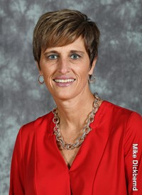

In her third season as IU women’s head basketball coach, **Teri Moren** will be the speaker when retirees gather at 2 p.m. on Nov. 9 at the Showalter House of the IU Foundation.

Fresh off a successful year in which she led the Hoosiers to their first NCAA Tournament berth in 14 years, Teri is only the second IU women’s basketball coach to be named Big Ten Coach of the Year. Last year’s team had the most regular season wins (20) in program history, finishing fourth in the Big Ten, the school’s highest conference finish in 18 years. That record represents a quick turnaround from Teri’s first season at IU, which started with only 10 scholarship players and ended with a 15-16 record.

Last season IU’s women went a perfect 14-0 at home in Assembly Hall, marking the most home wins ever without a defeat and tying for the most overall home victories in a single year in program history. The women’s team combined with the men’s team to go a perfect 31-0 inside of Assembly Hall in 2015-16 for the first unblemished home season in school history.

Before coming to IU, Teri was head coach at Indiana State University for four years. She spent three years as associate head coach at Georgia Tech. She began her head coaching career at the University of Indianapolis. Appropriately enough the IU women’s team begins this season in the newly remodeled Simon Skjodt Assembly Hall with an exhibition game against the University of Indianapolis on Nov. 6 at 2 p.m.

A native of Seymour, Ind., Teri was an Indiana All Star in 1987. She earned her bachelor’s degree at Purdue, where she was a two-year starter for the Boilermakers. She was part of three NCAA Tournament teams and Purdue’s first Big Ten championship. Teri was inducted into the Indiana Basketball Hall of Fame in 2014.

**Cromwell to outline online safety**

Following the regular IURA meeting Nov. 9, **Dennis Cromwell**, IU associate vice president for client services and support, will offer retirees best practices for computer security. He will discuss phishing, viruses, and other online safety concerns. This bonus feature will begin about 3 p.m.

**Deans discuss students then and now**

“When I started my career,” said former dean of students **Dick McKaig**, “only birds tweeted.” That was only one of the changes outlined by three deans of students who spoke to 55 rapt retirees on Oct. 19 at the Virgil T. DeVault Alumni Center.

Only seven people have served as dean of students at IU, and six are still living, including longtime IURA member **Bob Shaffer**, who recently celebrated his 101st birthday. Three of them – Dick (1991-2009), **Pete Goldsmith** (2009-June 2016), and **Lori Reesor** (July 2016-to date) spoke about the changes they have observed on their respective watches.

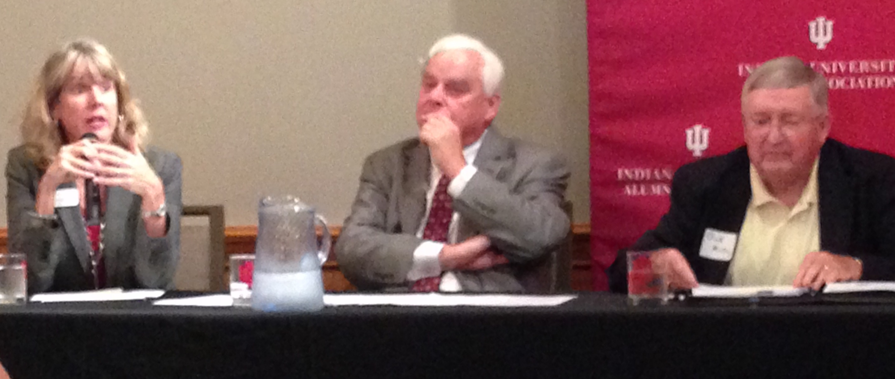**From left, Lori Reesor, Pete Goldsmith, and Dick McKaig discuss changes in student life.**

**Sense of community.** Dick has seen the campus grow from 30,000 to 43,000. One big difference has been the number of students living off campus. In 1971, when he came to Bloomington, 65 percent of students lived on campus. By 2009, when he retired, 65 percent lived *off* campus. Dick described the IU of today as a ring commuter campus instead of a residential campus. “It changes things,” he said. “They don’t come back for evening events.”

Because most students live on campus during their freshman year, Lori considers the first year formative as students find their comfort zone. Academic units are very strong at IU, she said, and students begin their affiliation with them early. “There is also so much identity and pride in being a Hoosier,” she said.

Because of their administrative duties – Lori has more than 40 direct reports – the deans have little time with students. In his contact with students, Pete said, “I saw the very good and the very bad.” Dick added that Bob Shaffer described the same phenomenon as “the wheels and the heels.”

Lori sees her job as being the students’ advocate. “I’m on Twitter, and I have open office hours every week,” she said.

**Changing attitudes.** Citing data from the Higher Education Research Institute, Dick described changing attitudes by comparing answers to questions about goals. In 1971, 73 percent of students thought developing a meaningful philosophy of life was an important part of their education; by 2015 only 47 percent considered it important. In 1971, 37 percent said being well off financially was important; in 2015, 82 percent considered it important.

IU emphasizes inclusion and being open-minded. Inevitably, Lori said, students who come from small rural communities in Indiana will find their ideas clashing with those from more cosmopolitan environments like New York City and New Jersey.

Although more students identify themselves as liberal than conservative, the number of self-identified conservatives has grown, Dick said. But commitment to diversity has grown. While in 1971 some 44 percent of students approved of laws outlawing homosexual relationships, 81 percent favored same-sex marriage in 2015.

**Expectations**. Lori pointed out that in today’s world, where everything is live and virtual, students expect instant responses. Parents too expect the university to respond to them. As the mother of a seventh- and a ninth-grader, she said, “I get a daily update. I can see their homework assignments and their grades. That is the expectation parents are bringing from K-12.”

In 1971, only 30 percent of students had parents who had gone to college, Dick said. By 2015, 60 percent of students had college-educated parents. In 1971, he said, student government was more like a caucus or labor union. By 2015, students were more conservative and trusting of authority, and the emphasis was on being professional.

Pete recalled that in the 1960s students didn’t worry about how to pay for education. Grants were readily available. Beginning in the 1980s, he said, attitudes changed in society: “College education was seen as a private, not a public, benefit, and people should pay for it.” State support dropped, and costs went up.

**Sexual assault**. Sexual assault is a significant concern. “When I was in school,” said Lori, who graduated from the University of Wisconsin-Whitewater in 1984, “one out of ten women said they were victims of sexual violence. Now that number is one in four. I worry about our staff, who have to spend so much time on such a difficult subject.”

Pete pointed out that, as part of Title IX, the Office for Civil Rights in 2011 outlined specific procedures schools needed to follow in cases of sexual harassment and violence. Because grievance procedures, employee training, and investigation of complaints were mandated, the dean’s office had to figure out how to train faculty. At the same time debate was going on about whether law enforcement rather than the university should be in charge of investigating such charges. “It was a very difficult time for all of us,” he said.

These unfunded mandates, requests for data and for generation of reports, mean more administrative duties, Pete said.

The discussion showed the complexity of the position and the dedication of those who hold it. “I wouldn’t be in this role if I didn’t love students,” Lori said. As the first woman dean of students, she said with a smile, “I have big shoes to fill, but I’m wearing high heels.”

In introducing the panel, IURA President **Joanie Curts** quoted the dean of students from another Big Ten university, who said, “I’m in charge of wildlife.” Retirees were more sedate as they engaged in conversation after the meeting, comparing experiences and observations. In discussing the increase in sexual assault, for example, **Carolyn Huffman** pointed out that, when she was an IU student in the 1960s, women had to be in their dorms by 10:30 p.m.

Special thanks to providers of snacks: **Mary Ellen Anderson**, **Carol** and **Bill McGregor**, **Suzann Owen**, and **Ralf Shaw**, who also served as photographer.

**University Club, Emeriti House programs**

Many IURA members participate in the programs of our partner organizations, the Emeriti House and University Club. For information on these organizations, see:

<http://www.indiana.edu/~emeriti> and

[www.indiana.edu/~uclub](http://www.indiana.edu/~uclub)

**Double your whammy, Sherman urges**

A special giving opportunity is available to retired

faculty and staff as part of IU’s 200th birthday campaign. At the Oct. 19 meeting of the IURA, **Jim Sherman**, professor emeritus of psychological and brain sciences, described an endowment plan in which retirees can participate. More than half of the campaign goal of $2.5 billion already has been raised, Jim told retirees.

During this campaign the initial income from an endowment gift of $25,000 or more from faculty and staff, including retirees, will be doubled by funds from the president’s discretionary fund. Jim outlined ways retirees can give, some with significant tax advantages. For example, a donor can sign over the deed to her or his home, live in it until death, and get the tax deduction for the property right away. Or a donor over age 70½ in age can roll over funds from a retirement account, up to the required minimum distribution, directly to the IU Foundation without having to include the distribution as income for tax purposes. Or contribute appreciated stock without having to pay capital gains.

Jim outlined three reasons for giving:

1. Reciprocity. IU contributed to your retirement fund, and some faculty members benefited through the 18/20 plan.

2. Loyalty. “I have formed an incredible attachment to IU,” Jim said. “IU affords attachment.”

3. Legacy. “You can endow something you'd really like to see done, something for which you have

a passion,” Jim explained. The endowments are not limited to scholarships or academic units. Jim and his wife, Roberta, for example, have endowed IU Cinema.

“If you are contemplating a current or future   
(planned) gift to any part of IU, it is wise to do it during this campaign with the matching offer,” Jim said. If you have questions or would like to meet with Jim, email him at [sherman@indiana.edu](mailto:sherman@indiana.edu).

**You've got what it takes: Volunteer**

**with AARP Foundation Tax-Aide**

With the help of people like you, *AARP Foundation Tax-Aide* offers free tax-filing help to those who need it most. Tax-Aide is looking for compassionate and friendly individuals to join a team of local volunteers for the upcoming tax season. In January you’ll receive training – more than 20 hours’ worth – in income tax law and tax preparation to become IRS-certified. You will also receive continued support in a welcoming environment, while providing free federal and state income tax preparation to anyone, with special attention to older, low-income taxpayers.

From February to April Tax-Aide will conduct preparation sessions at the Monroe County Public Library and Twin Lakes Recreation Center. Hours are flexible, but volunteers are encouraged to work at least three hours per week. And, as current Tax-Aide volunteers report, you’ll not only learn new skills, but also get a great feeling from helping someone else.

For more information, call **Doris Wittenburg**at 812-336-4993.

**IU Retirees Association Nonprofit Org.**

**P.O. Box 8393 U.S. Postage PAID**

**Bloomington, IN 47407-8393 Bloomington, IN**

**Permit No. 2**

**Is this your final newsletter?**

People who do not pay their 2016 membership dues before the next newsletter in mid-November will be dropped from the distribution list. Check your mailing label to see your status:

“2016 DUES PAID--THANK YOU!” indicates you are one of the IURA’s 338 current members –126 singles and 106 couples.

“PLEASE RENEW FOR 2016” means you have been a member in the past but have not yet renewed.

“PLEASE JOIN FOR 2016” indicates you are not a recent member but are invited to join the IURA.

To join, please complete and return the membership form below. If you have signed up for email delivery, this is your final printed copy.

**Judy Schroeder** writes *Newswatch* eight times a year. Please send corrections and comments to her at [jschroed@indiana.edu](mailto:jschroed@indiana.edu).To update your address, send a message to database manager **Doris Wittenburg,** [dwittenb@indiana.edu](mailto:dwittenb@indiana.edu).

**- - - - - - - - - - - - - - - - - - - - - - - - - - - - - - - - - - - - - - - - - - - - - - - - - - - - - - - - - - - - - - - - - - - - - - - -**

**IU Retirees Association**

**2016-2017 MEMBERSHIP FORM**

Name_______________________________________________________________________

For couple membership, spouse’s/partner’s name____________________________________

Address ____________________________________________________________________

City ____________________________State______9-digit ZIP code____________________

Telephone­* ______________________E-mail* ____________________________________

*Telephone number and e-mail will be included in membership directory only if you write them here.

Enclosed is my check, made payable to IU Retirees Association, for:

__________Single membership ($15) __________Couple membership ($20)

Please mail this form with your check to IU Retirees Association

P.O. Box 8393

Bloomington, IN 47407-8393

____ I wish to receive the newsletter by e-mail rather than in paper form.