NEWSWATCH



**Vol. 2018-2019 No. 1 August 2018**

**________________________________________________________________________________­­­­­­__**

**Next meeting: 11:30 a.m., Wednesday, Sept. 12 (reservation deadline Sept. 5)**

**The Commons, Bell Trace Senior Living Center, 800 N. Bell Trace Circle**



**It’s time to renew your membership**

Welcome back to returning members of the IU Retirees Association! As another academic year begins, we look forward to your “re-upping.” Dues ($20 for individuals, $30 for couples) cover the period September 2018 through May 2019.

“This spring Treasurer **Tom Hustad** presented reports that indicated expenses increasing faster than income,” IURA President **Doug Porter** says. “The dues increase of $5 per member will allow us to support services that our members appreciate and preserve a safety margin for operations.” The increase has been more than offset by making the September luncheon complimentary to dues-paid members.

The Retirees Association provides a voice for retirees in their continuing relationship with Indiana University. The organization is entirely self-funded and receives no university support, although the IU Foundation generously provides meeting space at no charge. Our meetings offer an opportunity to exchange ideas, information, and friendship.

**September to feature Peace Choir**

When the IU Retirees Association meets for its Sept. 12 luncheon at Bell Trace, it will start off the academic year with a song – actually, with many of them. Members of the Bloomington Peace Choir will offer a short concert and a (strictly optional) sing-along. Founded in 2010, the choir is a non-audition community group with the missions of singing for the joy of it and of sharing music from around the world.

Bell Trace is hosting the luncheon, which is **only for IURA dues-paid members** and requires a reservation. Please reserve your spot by checking the appropriate box on the membership form and returning it by Sept. 5.

The luncheon buffet will feature braised chicken, artichokes and roasted potatoes, mixed field greens salad with assorted condiments, rolls and butter, and choice of dessert. Vegetarian and gluten- and sugar-free options will be available.

Bell Trace is making about 50 spaces available surrounding the main building, and overflow parking will be available in a lot across Tenth Street. Shuttle service will be provided from the overflow lot. Carpooling is encouraged.

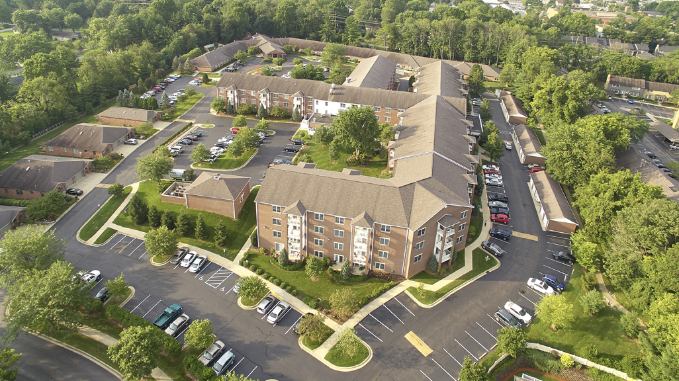

“Last April many people suggested Bell Trace as a possible IURA venue,” says hospitality co-chair **Gail Londergan**. On its 15-acre campus near the Woodbridge Post Office, Bell Trace has been offering independent and assisted living and specialized health care services to seniors in Bloomington for the past 20 years.

Doors open at 11:30 a.m., and the program will begin about 12:15 p.m. Address questions to Gail at [londer@indiana.edu](mailto:londer@indiana.edu).

**Tine Lindemann appointed to IURA board**

At its June 6 meeting, the IURA board appointed **Kirstine “Tine” Lindemann** to complete the term of **Carol Stokes**, who resigned in December. Tine came to Bloomington in 1980 as a graduate student and retired from IU in 2015. She taught in the Department of Germanic Studies and served in various capacities in the College of Arts and Sciences Dean’s Office. Tine earned her Ph.D. in 1992 but says that only in retirement has she found time to read. She co-chairs the Hospitality Committee with Gail Londergan.

**Meadowood hosts May dinner**

More than 110 eager and convivial eaters gathered at Meadowood on May 9 for the final meeting of the 2017-18 academic year. Director of Sales and Marketing **Kathy Norris** and Activities/Hospitality Director **Mark Kraner** greeted us. Kathy introduced **Alan Booze**, head chef, who has been at Meadowood for 16 years. He heads a kitchen staff with more than 100 years of experience and is one of eight elite chefs of 280 chefs in the Five-Star Living Community.

While diners raved about the pork tenderloin with bourbon apple chutney, IURA President **Joanie Curts** saluted fellow board members. She announced that **Harriet Pfister**, who has anchored the IURA’s United Way efforts for decades, is retiring from the post. **Eileen Schell-hammer** ([eileenschellhammer@comcast.net](mailto:eileenschellhammer@comcast.net)) is actively looking for assistance. Please contact her for details about what is involved.

Incoming president **Doug Porter** toasted Joanie on completing her second year as president and presented her with a bottle of wine. “What I know about wine is that there are red kinds and white kinds, and that most people choose by the cute animal on the label,” Doug quipped. “But the best wine is the one you share with friends.”

Jacobs School of Music student **SeungAh Hong**, first-prizewinner at the 2018 Indianapolis Matinee Musicale Competition, beautifully played Bach Cello Suite No. 3 in C Major.

**Remembering our friends**

***Twice a year since 2008, in the April and August issues,* Newswatch *memorializes members who have died since the last listing. Because of space limitations, only IURA members can be included. Please notify me (***[*jschroed@indiana.edu*](mailto:jschroed@indiana.edu)***, 812-332-5057) of any omissions.***

***Judy Schroeder,* Newswatch *Editor***

**Robert LeRoy Bannerman died June 13 in Bloomington. He was 97. A native of Whiteville, N.C., he was stationed in England with the U.S. Army Air Force during World War II. He earned his bachelor’s degree at the University of North Carolina and a master’s at the University of Alabama. LeRoy came to Bloomington in 1957 as a writer and producer for Radio and TV Services and an assistant professor of radio and TV.** He wrote and produced more than 200 hours’ worth of radio programs. In 1963, he wrote and produced a historical radio docudrama, *Tears of Rain*, which chronicled and interwove the stories of the Kennedy and Lincoln assassinations. He was the author of several books: about **Norman Corwin and the golden years of radio; the home front and World War II as the “radio war”; and a civil rights novel. In 1986-89 he was a member of the board of the IU Annuitants Association, the precursor of the IU Retirees Association.**

**Jean Hill White Campaigne died July 17 in Bloomington. She was 97. She was born in Ayrshire, Scotland, but her family immigrated to Chicago when she was young. She married in 1941 and moved to Bloomington in 1943. From 1961 to 2003 Jean contributed more than 3,500 hours of service as a Bloomington Hospital Auxiliary volunteer. She served on the hospital’s board of directors and was the first president of the Southern Indiana Women’s Hospital Auxiliary. She was president of the Bloomington Local Council of Women and a member of P.E.O. and Psi Iota Xi philanthropic sorority. Ernest, her husband, president in 1987-88 of the IU Annuitants Association, the precursor of the IURA, died in 2013.**

**Rebecca Fowler Covey died Dec. 27, 2017, in Solsberry, Ind. She was 71. A Bloomington native, she graduated from Bloomington High School before attending IU. Becky was services coordinator within the Department of Speech and Hearing Sciences. She enjoyed baking, fishing, and bird watching. A member of the Clear Creek Christian Church, she participated in Kairos prison ministry and was active in the Hoosier Hills Emmaus Community.**

**Marjorie Macy Hattin died May 12 in Bloomington. She was 87. Born in Cohasset, Mass., she met her future husband, Don, when she was 15. They were married when she was 20 and moved to the University of Kansas, where Don earned his Ph.D. and Margie was secretary to the head football coach. They came to Bloomington in 1954. An enthusiastic camper, Margie served as support staff for Don’s geology field trips to Kansas, Colorado, the Florida Keys, and the Bahamas. She enjoyed bridge, football, gardening, sewing, needlepoint, weaving, and cross-stitch. She was a Brownie and Girl Scout leader, a Pink Lady at Bloomington Hospital, and a Red Cross volunteer. A member of First United Church, she was active in the University Women’s Club and Tri Kappa service sorority. Don, her husband of 65 years, died in 2016.**

**John McAdow Miller died June 27 in Bloomington. He was 89. A native of Iowa City, Iowa, he earned both bachelor and medical degrees at the University of Iowa. After service as a medical officer in the U.S. Navy, he joined IU’s Student Health Service in 1957. He was appointed director in 1962. In 1978 he became director of sports medicine and part-time professor of physical education. He retired in 1994. He served as president of the American College Health Association, the Sports Equipment Research Foundation, and the National Operating Committee on Standards for Athletic Equipment. At various times he was president of the Owen-Monroe Medical Society, the Monroe County Public Health Nursing Association, Monroe County United Ministries, and the Bloomington Rotary Club. John was a fellow of the American College of Sports Medicine and the American College Health Association, which honored him for distinguished service. He received IU’s E. Ross Bartley award for outstanding service in 1993. He was a Sagamore of the Wabash. A board member of the Salvation Army for 44 years, John was an elder, deacon, trustee, and chair of the board of First Christian Church. Gerry, his wife of 67 years, survives.**

**Snacks, anyone?**

Because of a change in the IU Foundation’s food service policy, IURA events held there cannot serve homemade items. Hospitality committee members **Sally Dunn**, **Tine Lindemann**, and **Gail Londergan** are proposing that a snack coordinator choose and purchase food for the five meetings that do not involve a meal. **Bonnie Brownlee** has volunteered to be the first coordinator.

The IURA will reimburse each month’s coordinator up to $30 for purchases. To volunteer, please contact any member of the hospitality committee.

**A peek at the future: coming attractions**

https://www.exchange.iu.edu/owa/14.2.247.5/themes/resources/clear1x1.gifhttps://www.exchange.iu.edu/owa/14.2.247.5/themes/resources/clear1x1.gifIfkiesling

Here are some dates for your calendar. Meetings at the IU Foundation are in the Peterson Room.

Thanks you Dick I think that is a good suggestion about listing topics. It may generate some more ideas. Thank you and your cmmittee for getting this going. I'm out of town July 12 until July 19 but am accessible at leat by cell phone 812-325-4348 and infrequently

Thu 7:37 AM

* Oct. 10 at 2 p.m., speaker and location TBD
* Nov. 14 at 2 p.m., IUF, **Beth Cate,** The Supreme Court today

**IU Retirees Association Nonprofit Org.**

**P.O. Box 8393 U.S. Postage PAID**

**Bloomington, IN 47407-8393 Bloomington, IN**

**Permit No. 2**

* Dec. 12 at 11:30 a.m., IUF, holiday luncheon catered by **David Tallent**, who is also the speaker
* Jan. 16 at 2 p.m., IUF, **Phil Stafford**, The Meaning of Home and “Stuff”
* Feb. 13 at 2 p.m., IUF, **Bill Brown**, IU’s Center for Rural Engagement
* April 17 at 2 p.m., IUF, **Kristin Leaman**, The People’s History of IU
* May 8 at 5 p.m., potluck dinner at Bell Trace, **Jeff Wuslich**, Cardinal Spirits, about business innovation in Bloomington

**About this newsletter**

Founded in 1975 as the IU Annuitants Association, the IURA welcomes all retired faculty and staff and their spouses or partners.

*Newswatch* is published eight times each year, August through April, except for February. To correct your address or be removed from the list, please contact database manager **Doris Wittenburg**, [dwittenb@indiana.edu](mailto:dwittenb@indiana.edu). Send comments or corrections to *Newswatch* editor **Judy Schroeder**, [jschroed@indiana.edu](mailto:jschroed@indiana.edu).